INVESTIGATE

MODULE 1: CHOOSING AN AUTHENTIC PROBLEM TO SOLVE (70 minutes)

LEARNING INTENTIONS
In this module, students will:
- Identify problems that could be making their local community and environment more vulnerable to impacts of bushfire hazards.
- choose a relevant and authentic problem to focus on for their project
- form project teams based on the problems they have chosen
- identify the characteristics of an effective team

VICTORIAN CURRICULUM CONNECTIONS 2.0
GEOGRAPHY
Geographical knowledge and understanding
Management of places
- how places and environments are changed and managed by people (VC2HG6K01)
- the specific geographical and other characteristics that shape their place, how their place is changing and how change is managed (VC2HG6K03)
- the importance of sustainability to places and environments, including the custodial responsibility Aboriginal and Torres Strait Islander Peoples have for Country and Place and how it influences their sustainability practices (VC2HG6K04)
- the impacts of bushfires and other climate hazards on environments and communities, and how people and communities manage prevention, preparedness, response and recovery (VC2HG6K05)

Geographical Skills
- interpret and analyse information and data in a range of formats to identify and describe patterns and trends, or to infer relationships (VC2HG6S04)

Concluding and decision-making
- propose actions or responses to issues or challenges in land management and use criteria to assess the possible impacts (VC2HG6S06)

Communicating
- develop explanations that draw ideas and findings from sources and use relevant geographical knowledge and concepts (VC2HG6S07)

PERSONAL AND SOCIAL CAPABILITY
Self-awareness and management
Collaboration
- the characteristics of an effective team and team roles including leadership roles; strategies for reflecting on performance in a team role (VC2CP6O04)
- strategies and skills for preventing, defusing or resolving conflict, considering possible causes and effects of conflict in different situation (VC2CP6O05)

CRITICAL AND CREATIVE THINKING
Questions and possibilities
- the construction of questions for identifying and building understanding of information, possibilities, processes and activities (VC2CC6Q01)
- the importance of setting aside preconceptions; strategies for setting preconceptions aside when generating and evaluating alternative ideas and possibilities (VC2CC6Q02)

Reasoning
- ways to identify, structure and communicate an argument that uses sub-arguments leading to a main conclusion (VC2CC6R01)

MATERIALS AND RESOURCES
- Sticky notes
- Large piece of poster paper
- Student learning journals
- Manila folders (one for each project team)

PART 1: BRAINSTORMING POTENTIAL PROBLEMS (30 minutes)
- Facilitate a class discussion to review the key learnings from Module 5: Bushfire Risk. Suggested prompt:

According to the bushfire scientists who study bushfire events, what are some of the problems that make communities and environments more vulnerable to the impacts of bushfires?

For each problem the students invite them to explain why it is a problem.

NB: The five problems addressed in Module 5 are listed below:
- People don’t know that they live in bushfire prone area that could be impacted by bushfire hazards.
- People don’t do everything they can to prepare their property for bushfire season.
- The Fire Danger Rating System provides really important information that people can use to stay safe from bushfires, but a lot of people don’t know how to use it.
- People don’t tune in to bushfire warnings during bushfire season.
- People don’t make detailed bushfire survival plans.

- Tell the students they are going to brainstorm problems that could be making their own local community and environment more vulnerable to the impacts of bushfire hazards.

Write the focus question for the brainstorming session on the board:

What problems are making our local community and environment more vulnerable to the impacts of bushfire hazards?

Invite a couple of students to share their ideas. NB: They may identify the problems from Module 5 and that is fine.

- Organise the students into groups of 4 or 5. Provide each group with a stack of sticky notes. Instruct the groups to brainstorm problems that could be making their own local community and environment more vulnerable to the impacts of bushfire hazards, writing down each one on its own sticky note. Allow 10-15 minutes for the students to brainstorm as many problems as they can.

- At the end of the brainstorming session, invite each group to share the problems they have identified with the rest of the class and add their sticky notes to a class list (this could be a large piece of poster paper at the front of the room). Sticky notes which describe the same problem can be clustered together on the list.

PART 2: CHOOSING A PROBLEM TO SOLVE (20 minutes)
- Think-Pair-Share: Write the questions below on the board.

Which problem interests you the most? Why?

Which problem concerns you the most? Why?

Which problem is the most important to solve? Why?

Ask the students look at the problems on the class list. Give them a few minutes to think about their responses to each question. Then give them a few minutes to discuss their responses with a partner. Invite some of the students to share their partner’s thinking.

- Tell the students that it is now time for them to choose one problem to focus on for their project. They can use the discussion questions above to guide their decision-making process. They may also like to engage in discussion with another student to help them decide.

- Instruct students to record the problem they have chosen in their learning journal. Provide a couple of minutes for students to reflect on the reasons for the choice and record those reasons in their learning journal.

- When all the students have completed this task, invite each student to share the problem they have chosen and their reasons for choosing it. Tell the students to listen carefully to each other and take note of other students who have chosen the same or a similar problem. Alternatively, students can do a gallery walk and read each other’s choices, taking note of other students who want to solve the same or a similar problem.

PART 3: FORMING PROJECT TEAMS (20 minutes)
- Support the students to form project teams based on the problems they have chosen. They may have identified potential teammates in the previous step.
NB: Teams of 3 to 5 students are ideal. However, teams of two will also work. There may be students who wish to work alone. The decision as to whether students can work alone is one for the teacher.
- Organize the students into their project teams. Give the teams a few minutes to come up with a team name.

- Provide each team with a manilla folder and instruct them to write their team name and the name of each team member on the cover. Tell them that this is where they will store their work during the project.
At this stage, it may also be useful to set up a system that teams can use to store digital material they collect and produce throughout the project (e.g. google drive or google classroom).

PART 4: IDENTIFYING CHARACTERISTICS OF EFFECTIVE TEAMS (10 minutes)
- Engage the students in a discussion about the characteristics of effective teams and develop criteria against which project teams can evaluate their own and their team’s performance as they seek to develop a solution to their chosen problem.

- Students can record the criteria in their learning journal and use them to evaluate their own and their team’s performance at key points in their learning journey.

- The students may also like to write the criteria for an effective team on the inside cover of their manilla folder.

MODULE 2: DEFINING THE PROBLEM (80 minutes)

LEARNING INTENTIONS
In this module, students will:
- create an initial problem statement that clearly defines the problem
- present their problem statement to the class and give and receive critical feedback
- evaluate and refine their problem statement in response to critical feedback

VICTORIAN CURRICULUM CONNECTIONS 2.0
Geography
Geographical knowledge and understanding
Management of places
- how places and environments are changed and managed by people (VC2HG6K01)
- the specific geographical and other characteristics that shape their place, how their place is changing and how change is managed (VC2HG6K03)
- the importance of sustainability to places and environments, including the custodial responsibility Aboriginal and Torres Strait Islander Peoples have for Country and Place and how it influences their sustainability practices (VC2HG6K04)
- the impacts of bushfires and other climate hazards on environments and communities, and how people and communities manage prevention, preparedness, response and recovery (VC2HG6K05)

Geographical skills
Geographical Inquiry
- develop a range of geographical questions on how places are managed (VC2HG6S0)
- locate, collect and organise information and data from primary and secondary sources, including from fieldwork (VC2HG6S02)
- represent information and data collected using maps that conform to cartographic conventions, graphs, tables, sketches and other formats (VC2HG6S03)
- interpret and analyse information and data in a range of formats to identify and describe patterns and trends, or to infer relationships (VC2HG6S04)

Concluding and decision-making
- develop evidence-based conclusions on the management of places using the concepts of place, interconnection, environment and sustainability
(VC2HG6S05)

Communicating
- develop explanations that draw ideas and findings from sources and use relevant geographical knowledge and concepts (VC2HG6S0)

ENGLISH
Level 5 - Literacy
Analysing, intepreting and evaluating
- use comprehension strategies, such as visualising, predicting, connecting, summarising, monitoring and questioning, to evaluate information and ideas to build literal and inferred meanings (VC2E5LY09)

Level 6 - Literacy
Analysing, intepreting and evaluating
- use comprehension strategies, such as visualising, predicting, connecting, summarising, monitoring and questioning, and connect and compare ideas from a variety of sources to build literal and inferred meanings (VC2E6LY08)

CRITICAL AND CREATIVE THINKING
Questions and possibilities
- an extended range of strategies to generate new ideas and possibilities including forming a link between different information sources (VC2CC6Q03)

Reasoning
- ways to consider competing values and the strength of evidence when reasoning (VC2CC6R02)
- the use of criteria to support analysis and evaluation when reasoning (VC2CC6R04)

MATERIALS AND RESOURCES
- Problem statement worksheets (one for each student)
- Student learning journals

PART 1: DEVELOPING A DRAFT PROBLEM STATEMENT (25 minutes)
- Seat students in their project teams and allow couple of minutes for them to review the problem they have chosen to solve. Invite a couple of students to share the problem their group has chosen.

- Provide each student with a Problem Statement Worksheet (linked here). Focus students’ attention on page 1. Read through the information with the class, taking time to discuss the five questions and the worked example.

- Focus students’ attention on page 2 of the worksheet. Allow a few minutes for the project teams to discuss their response to Question 1 and record their response on the worksheet. Invite some students from different project teams to share their responses to Question 1.

- Allow about 15 minutes for the project teams to discuss and record responses to the other four questions on their problem statement worksheets. They should discuss and decide upon the answers as a team, but they should complete their own individual worksheet. Tell the students that each project team will be presenting their problem statements to the class in the next activity.

PART 2: CLASS PRESENTATIONS (30 minutes)
- When students have recorded their answers to the 5 questions on their Problem Statement Worksheets, invite each project team to present their problem statement to the class.
As each project team presents their answers, use the following questions to clarify and interrogate the ideas in the problem statements and elicit critical feedback from the rest of the class.

- What is the current situation?
- Who agrees that this is the current situation in our community? Why/Why not?
- What have you seen or heard to make you think that this is the current situation in our community?

- Why is this a problem?
- Do you agree that this is a problem? Why/Why not?
- Are there any other reasons why this is a problem?

- Where is the problem occurring?
- Do you agree that this is where the problem is occurring? Why/Why not?
- Is the problem occurring everywhere in our community or just in particular areas?
- Have you seen or heard of this problem occurring in a specific area/location?

- Who is affected by the problem?
- Are you affected by this problem?
- Do you know anyone who is affected by this problem?
- Are some people in our community more likely to be affected by this problem than others?

- What is the desired future state?
- Do you think this desired future state is possible? Why/Why not?
- Do you think you will come up against any challenges or obstacles as you try to achieve this desired future state?

PART 3: REFINING THE PROBLEM STATEMENT (25 minutes)
- Allow a few minutes for project teams to reflect on the feedback they received on their problem statement and identify how it can be improved. Students can then write their revised problem statement into their learning journal.

PROBLEM STATEMENT WORKSHEET

WHAT IS A PROBLEM STATEMENT?
A problem statement clearly defines the problem that we want to solve. Before we can solve a problem, we need to have a very clear idea of the problem we are trying to solve. So, we need to develop a problem statement.
A good problem statement provides answers to five important questions.
- What is the current situation?
- Why is this a problem?
- Where is the problem occurring?
- Who is affected by the problem?
- What is the desired future state?

EXAMPLE
- What is the current situation?
People in bushfire prone areas are not planning to leave early on Catastrophic Fire Danger days.

- Why is this a problem?
If a fire starts on a Catastrophic fire danger day, it will spread very quickly and people’s lives will be at risk.

- Where is the problem occurring?
The problem is occurring in bushfire prone areas in our local area.

- Who is affected by the problem?
People living in bushfire prone areas are affected because if a fire starts their lives could be at risk. The local fire brigade is affected because they will have to try and rescue people who get trapped in the fire zone.

- What is the desired future state?
People in bushfire prone areas will plan to leave the night before or early in the morning on Catastrophic fire danger days.
OUR PROBLEM STATEMENT
Think about the problem you have chosen to solve. Discuss the answers to each question with your team members. When your team has agreed on an answer, write it down in the box provided.

- What is the current situation?
____________________________________________________________________________
____________________________________________________________________________
____________________________________________________________________________
________________________________________________________________________________________________________________________________________________________
____________________________________________________________________________
____________________________________________________________________________

- Why is this a problem?
________________________________________________________________________________________________________________________________________________________
____________________________________________________________________________
________________________________________________________________________________________________________________________________________________________
____________________________________________________________________________
____________________________________________________________________________

- Where is the problem occurring?
________________________________________________________________________________________________________________________________________________________
____________________________________________________________________________
________________________________________________________________________________________________________________________________________________________
____________________________________________________________________________
____________________________________________________________________________

- Who is affected by the problem?
________________________________________________________________________________________________________________________________________________________
____________________________________________________________________________
________________________________________________________________________________________________________________________________________________________
____________________________________________________________________________
____________________________________________________________________________

- What is the desired future state?
________________________________________________________________________________________________________________________________________________________
____________________________________________________________________________
________________________________________________________________________________________________________________________________________________________
____________________________________________________________________________
____________________________________________________________________________

MODULE 3: CONDUCTING ONLINE RESEARCH (80 minutes)

LEARNING INTENTIONS
In this module, students will:
- locate trustworthy, credible digital resources that are relevant the problem they are trying to solve.
- analyse digital resources and summarise key ideas and concepts in a mind map.

VICTORIAN CURRICULUM CONNECTIONS 2.0
GEOGRAPHY
Geographical knowledge and understanding
Management of places
- how places and environments are changed and managed by people (VC2HG6K01)
- the specific geographical and other characteristics that shape their place, how their place is changing and how change is managed (VC2HG6K03)
- the importance of sustainability to places and environments, including the custodial responsibility Aboriginal and Torres Strait Islander Peoples have for Country and Place and how it influences their sustainability practices (VC2HG6K04)
- the impacts of bushfires and other climate hazards on environments and communities, and how people and communities manage prevention, preparedness, response and recovery (VC2HG6K05)

Geographical Skills
Geographical inquiry
- develop a range of geographical questions on how places are managed (VC2HG6S01)
- locate, collect and organise information and data from primary and secondary sources, including from fieldwork (VC2HG6S02)
- represent information and data collected using maps that conform to cartographic conventions, graphs, tables, sketches and other formats (VC2HG6S03)

Concluding and decision-making
- develop evidence-based conclusions on the management of places using the concepts of place, interconnection, environment and sustainability (VC2HG6S05)

Communicating
- develop explanations that draw ideas and findings from sources and use relevant geographical knowledge and concepts (VC2HG6S0)

SCIENCE
Science Inquiry
Communicating
- scientific ideas, findings, patterns, trends and relationships can be communicated for a specific purpose and audience, using various presentation formats, scientific vocabulary and digital tools as appropriate (VC2S6I06)

ENGLISH
Level 5 – Literacy
Building fluency and meaning-making
- read different types of increasingly complex texts, integrating phonic, semantic and grammatical knowledge to read accurately and fluently for meaning, re-reading and self-correcting when needed (VC2E5LY06)

Analysing, interpreting and evaluating
- use comprehension strategies, such as visualising, predicting, connecting, summarising, monitoring and questioning, to evaluate information and ideas to build literal and inferred meanings (VC2E5LY09)

Creating texts
- create different types of texts, written and spoken, with relevant, elaborated and sequenced ideas, using text structure appropriate for topic, purpose and audience, and multimodal elements as appropriate (VC2E5LY10)

Level 6 – Literacy
Building fluency and meaning making
- select and read different types of texts of varying complexity, integrating phonic, semantic and grammatical knowledge to read accurately and fluently for meaning, re-reading and self-correcting when needed (VC2E6LY05)

Analysing, interpreting and evaluating
- use comprehension strategies, such as visualising, predicting, connecting, summarising, monitoring and questioning, and connect and compare ideas from a variety of sources to build literal and inferred meanings (VC2E6LY08)

Creating texts
- create different types of texts, written and spoken, with developed and organised ideas for purpose and audience, and multimodal elements as appropriate (VC2E6LY09)

CRITICAL AND CREATIVE THINKING
Question and possibilities
- the construction of questions for identifying and building understanding of information, possibilities, processes and activities (VC2CC6Q01)
- the importance of setting aside preconceptions; strategies for setting preconceptions aside when generating and evaluating alternative ideas and possibilities (VC2CC6Q02)

Reasoning
- ways to identify, structure and communicate an argument that uses sub-arguments leading to a main conclusion (VC2CC6R01)
- ways to consider competing values and the strength of evidence when reasoning (VC2CC6R02)
- simple reasoning errors including hasty generalisations, false analogies and contradiction, and how reasoning associated with these errors can be improved (VC2CC6R03)
- the use of criteria to support analysis and evaluation when reasoning (VC2CC6R04)

Metacognition
- learning strategies suited to general and specific contexts, including different ways of identifying, expressing and organising key learning, and undertaking spaced practice (VC2CC6M01)
- thinking processes suited to different contexts and when and how to use them, including for problem-solving (VC2CC6M02)

MATERIALS AND RESOURCES
- Wifi enabled digital devices for locating digital resources
- Student learning journals

PART 1: LOCATING DIGITAL RESOURCES (30 minutes)
- Ask the students where they could find up to date, trustworthy digital resources about their chosen problem (e.g. CFA website).

- Display the CFA website on a large screen. Demonstrate two methods for finding resources that are relevant to their problem on the CFA website:

Method 1: Search the ‘Warnings and restrictions’ and ‘Plan and Prepare’ areas of the website for key information related to the topic.
- On the CFA home page, point out the tabs for ‘Warnings and restrictions’ and ‘Plan and Prepare’.
- Click on the drop down menu for ‘Plan and Prepare’. Click on one of the options in the drop menu (e.g. ‘Before and During Fire’) and point out the links that appear for that option on the right hand side of the screen. Click on one of the links and scroll through to display the resource.
- Click on the drop down menu for ‘Warnings and Restrictions’. Click on one of the options in the drop menu (e.g. ‘Total fire bans and ratings) and highlight the resources available.

Method 2: Typing key words into the search bar.
- On the CFA home page, point out the search bar in the top right hand corner and enter a key word (e.g. pets). Ask the students to identify a relevant resource in the search results.
- Click on the search result and ask the students to confirm its relevance. If it is not relevant, move onto the next search result.

- Instruct students to create a table in word with the headings below. Using an example resource from the website, explain each column.

Name of resource | Author of resource | Type of resource | Date of resource | Web Link
Pets and Bushfires | CFA | Webpage | June 2021 | https://www.cfa.vic.gov.au/plan-prepare/before-and-during-a-fire/pets-and-bushfires
Pets and bushfires – a guide for pet owners | CFA | Flyer | August 2018 | https://www.cfa.vic.gov.au/articledocuments/534/Factsheet_Pets_A4-Flyer_2018.pdf.aspx
Planning for pets in emergencies | Animal Welfare Victoria | Webpage | March 2022 | https://agriculture.vic.gov.au/livestock-and-animals/animal-welfare-victoria/pets-and-emergencies/planning-for-pets-in-emergencies

- Allow 10-15 minutes for students to search the CFA website for resources that are relevant to their problem. They should start with Method 1 and if they can’t find any resources, move on to Method 2. Remind students to record the details of relevant resources in their table.

NB: The CFA website includes links to resources from other organisations, such as DEECA and the Red Cross and students can follow these links.

PART 2: ANALYSING AND SUMMARISING DIGITAL RESOURCES (50 minutes)
Students analyse the digital resources they have collected and summarise pertinent information in a mind map. They can continue to add ideas and concepts to the mind map throughout their learning journey.

MODULE 4: INTERVIEWING LOCAL PEOPLE (100 minutes)

LEARNING INTENTIONS
In this module, students will:
- discuss the importance of understanding the problem from the perspectives of local people
- develop interview questions to gain a deeper understanding of the problem from the perspectives of local people
- conduct interviews and record data
- analyse interview data and report on key findings

VICTORIAN CURRICULUM CONNECTIONS 2.0
GEOGRAPHY
Geographical knowledge and understanding
Management of places
- how places and environments are changed and managed by people (VC2HG6K01)
- the specific geographical and other characteristics that shape their place, how their place is changing and how change is managed (VC2HG6K03)
- the importance of sustainability to places and environments, including the custodial responsibility Aboriginal and Torres Strait Islander Peoples have for Country and Place and how it influences their sustainability practices (VC2HG6K04)
- the impacts of bushfires and other climate hazards on environments and communities, and how people and communities manage prevention, preparedness, response and recovery (VC2HG6K05)

Geographical skills
Geographical Inquiry
- develop a range of geographical questions on how places are managed (VC2HG6S0)
- locate, collect and organise information and data from primary and secondary sources, including from fieldwork (VC2HG6S02)
- represent information and data collected using maps that conform to cartographic conventions, graphs, tables, sketches and other formats (VC2HG6S03)
- interpret and analyse information and data in a range of formats to identify and describe patterns and trends, or to infer relationships (VC2HG6S04)

Concluding and decision-making
- develop evidence-based conclusions on the management of places using the concepts of place, interconnection, environment and sustainability (VC2HG6S05)

Communicating
- develop explanations that draw ideas and findings from sources and use relevant geographical knowledge and concepts (VC2HG6S0)

ENGLISH
Level 5 - Literacy
Interacting with others
- use interaction skills and awareness of formality when paraphrasing, questioning, clarifying and interrogating ideas; developing and supporting arguments; and sharing and evaluating information, experiences and opinions (VC2E6LY01)
- deliver structured spoken and multimodal texts to an intended audience for a specific purpose, using appropriate features of voice (VC2E6LY02)

Analysing, interpreting and evaluating
- use comprehension strategies, such as visualising, predicting, connecting, summarising, monitoring and questioning, to evaluate information and ideas to build literal and inferred meanings (VC2E5LY09)

Level 6 - Literacy
Interacting with others
- Interacting with others use interaction skills when discussing ideas and information, including evaluations of the features of texts (VC2E7LY01)
- deliver structured spoken texts for a specific purpose and audience, employing formal language and using appropriate features of voice and multimodal or digital elements (VC2E7LY02)

Analysing, interpreting and evaluating
- use comprehension strategies, such as visualising, predicting, connecting, summarising, monitoring and questioning, and connect and compare ideas from a variety of sources to build literal and inferred meanings (VC2E6LY08)

CRITICAL AND CREATIVE THINKING
Questions and possibilities
- the construction of questions for identifying and building understanding of information, possibilities, processes and activities (VC2CC6Q01)
- the importance of setting aside preconceptions; strategies for setting preconceptions aside when generating and evaluating alternative ideas and possibilities (VC2CC6Q02)
- an extended range of strategies to generate new ideas and possibilities including forming a link between different information sources (VC2CC6Q03)

PERSONAL AND SOCIAL CAPABILITY
Self-awareness and Management
Self-efficacy and sense of purpose
- what it means to be confident, adaptable and persistent; situations where these attributes are important; and what can and cannot be influenced through personal action (VC2CP6S04)

Social awareness and management
Relationships and diversity
- behaviours and attitudes that demonstrate sensitivity to individual, social and cultural differences, and why sensitivity to difference is important (VC2CP6O02)

MATERIALS AND RESOURCES
- Student learning journals
- Audio-recording equipment (optional)

PART 1: IDENTIFYING LOCAL PEOPLE TO INTERVIEW
- Engage students in a discussion about the importance of researching the problem in their own local context and understanding the problem from the perspectives of local people (use international and Australian examples of design failures that were not informed by the needs, behaviours, thoughts and feelings of local people (e.g. https://www.theguardian.com/commentisfree/2009/nov/24/africa-charity-water-pumps-roundabouts).

- Project teams work together to identify members of their school community they could interview to gain a deeper understanding of the problem from the perspectives of local people. Depending on the nature of the problem, they can interview fellow students, family members, family friends, or teachers. Ideally each project team member should identify 2 or 3 people they can interview.

PART 2: DEVELOPING AN INTERVIEW PROTOCOL
- Engage students in a discussion about questions designed to elicit quantitative and qualitive responses.

- Students brainstorm questions they could ask members of their local community to gain a deeper understanding of the problem from the perspectives of local people.

- Students select the most important questions and design an interview protocol they can use to conduct their interviews and record the responses of interviewees.

PART 3: CONDUCTING INTERVIEWS
- Students conduct their interviews and record the interview data.

PART 4: ANALYSING INTERVIEW DATA AND RECORDING KEY FINDINGS
- Project teams collate and analyse their interview data. They reflect on what they have learned from their interviewees and record key findings in their student learning journals.
- Students evaluate their problem statement in light of what they have learned through their online research and their community interviews, and they revise it accordingly (e.g. usage of correct terminology, disaggregating the problem into smaller elements or ideas and being more specific).

MODULE 5: EMAILING AN EXPERT
NB: This module is situated at this stage of the learning sequence so that interviews can be arranged by the time the students have developed their low fidelity prototypes in the Take Action phase.

LEARNING INTENTIONS
In this module, students will:
  - identify a subject matter expert who has detailed knowledge of the problem they are attempting to solve
  - plan, draft and send an email to a subject matter expert to request an interview

VICTORIAN CURRICULUM CONNECTIONS 2.0
ENGLISH
Level 5 – Language
Language for interaction with others
- understand how language varies as levels of formality and social distance change (VC2E6LA01)

Level 5 - Literacy
Interacting with others
- use interaction skills and awareness of formality when paraphrasing, questioning, clarifying and interrogating ideas; developing and supporting arguments; and sharing and evaluating information, experiences and opinions (VC2E6LY01)

Creating texts
- create different types of texts, written and spoken, with developed and organised ideas for purpose and audience, and multimodal elements as appropriate (VC2E6LY09)
- re-read and edit their own texts and the texts of others using agreed criteria and exploring editing choices (VC2E6LY10)

Level 6 - Literacy
Interacting with others
- use interaction skills when discussing ideas and information, including evaluations of the features of texts (VC2E7LY01)

Creating texts
- create different types of texts, written and spoken, selecting aspects of subject matter and particular language and print, multimodal and/or digital elements to convey information and ideas to a specific audience (VC2E7LY08)
- review and edit their own texts and the texts of others by removing repetition, refining ideas, reordering sentences and adding or substituting words for impact and coherence, and reflect on these processes (VC2E7LY09)

SCIENCE
Science as human endeavour
Use and influence of science
- scientific knowledge, skills and data can be used by individuals and communities to identify problems, consider responses and make decisions (VC2S6H02)

CRITICAL AND CREATIVE THINKING
Questions and possibilities
- the construction of questions for identifying and building understanding of information, possibilities, processes and activities (VC2CC6Q01)
- the importance of setting aside preconceptions; strategies for setting preconceptions aside when generating and evaluating alternative ideas and possibilities (VC2CC6Q02)
- an extended range of strategies to generate new ideas and possibilities including forming a link between different information sources (VC2CC6Q03)

PERSONAL AND SOCIAL CAPABILITY
Self-awareness and Management
Self-efficacy and sense of purpose
- what it means to be confident, adaptable and persistent; situations where these attributes are important; and what can and cannot be influenced through personal action (VC2CP6S04)

Social awareness and management
Relationships and diversity
- behaviours and attitudes that demonstrate sensitivity to individual, social and cultural differences, and why sensitivity to difference is important (VC2CP6O02)

MATERIALS AND RESOURCES
- Digital devices
- Learning Journals

PART 1: IDENTIFYING SUBJECT MATTER EXPERTS
Students conduct online research to identify a subject matter expert who has detailed knowledge of the problem they are attempting to solve. The expert could be a scientist, a local emergency management staff member or volunteer, or a community member with expert knowledge of the problem.

NB: Local program facilitators may also be able assist in the identification of subject matter experts.

PART 2: PLANNING AND DRAFTING AN EMAIL
Students plan and draft an email to a subject matter expert to request an interview. They identify and apply the conventions of formal email correspondence and use language features to demonstrate respect for the recipient.
The email should include:
- An introduction to the project team embers (names, grade, school).
- Information about the project (e.g. the problem the students are trying to solve and their idea for a solution)
- A polite request to conduct a short interview (20-25 minutes)
- The purpose of the interview (e.g. to ask the expert some questions about their area of expertise and to receive advice about their project)
- Possible interview formats (e.g. face to face, telephone, zoom)
- Possible times during which the interview could be conducted

NB: When project teams have finalised their emails, they can be sent from the teacher’s email account. The teacher can share the replies received from the experts and involve the students in writing responses and scheduling interviews. Ideally, the interviews should be conducted after the students have developed their low fidelity protype and had an opportunity to identify knowledge gaps and uncertainties (see Take Action, Module 3).

TAKE ACTION

MODULE 1: IDEATE (100 minutes)

LEARNING INTENTIONS
In this module, students will:
- develop questions that can generate ideas and possibilities for solutions to their chosen problem
- generate ideas for possible solutions to their problem
- evaluate the originality and feasibility of each idea
- select one idea for further development
- examine the connections between the problem, their idea and the desired outcome or result
- develop and present a pitch for their idea and give and receive critical feedback
- refine their idea in response to critical feedback

VICTORIAN CURRICULUM CONNECTONS 2.0
GEOGRAPHY
Geographical knowledge and understanding
Management of places
- how places and environments are changed and managed by people (VC2HG6K01)
- the importance of sustainability to places and environments, including the custodial responsibility Aboriginal and Torres Strait Islander Peoples have for Country and Place and how it influences their sustainability practices (VC2HG6K04)
- the impacts of bushfires and other climate hazards on environments and communities, and how people and communities manage prevention, preparedness, response and recovery (VC2HG6K05)

Geographical skills
Geographical Inquiry
- develop a range of geographical questions on how places are managed (VC2HG6S0)
- locate, collect and organise information and data from primary and secondary sources, including from fieldwork (VC2HG6S02)
- represent information and data collected using maps that conform to cartographic conventions, graphs, tables, sketches and other formats (VC2HG6S03)
- interpret and analyse information and data in a range of formats to identify and describe patterns and trends, or to infer relationships (VC2HG6S04)

Concluding and decision-making
- develop evidence-based conclusions on the management of places using the concepts of place, interconnection, environment and sustainability (VC2HG6S05)

Communicating
- develop explanations that draw ideas and findings from sources and use relevant geographical knowledge and concepts (VC2HG6S0)
- propose actions or responses to issues or challenges in land management and use criteria to assess the possible impacts (VC2HG6S06)

SCIENCE
Science as human endeavour
Use and influence of science
- scientific knowledge, skills and data can be used by individuals and communities to identify problems, consider responses and make decisions (VC2S6H02)

ENGLISH
Level 5 – Literacy
Interacting with others
- use interaction skills including paraphrasing and questioning to clarify meaning, make connections to personal experience or to a text, and present and justify an opinion or idea (VC2E5LY01)
- deliver structured spoken and multimodal texts to an audience for a specific purpose, using features of voice (VC2E5LY02)

Level 6 – Literacy
Interacting with others
- use interaction skills and awareness of formality when paraphrasing, questioning, clarifying and interrogating ideas; developing and supporting arguments; and sharing and evaluating information, experiences and opinions (VC2E6LY01)
- deliver structured spoken and multimodal texts to an intended audience for a specific purpose, using appropriate features of voice (VC2E6LY02)

TECHNOLOGIES - DESIGN AND TECHNOLOGIES
Creating designed solutions
Investigating and defining
- investigate needs or opportunities for designing, and the materials, components, tools and processes needed to create designed solutions (VC2TDE6D01)

Generating and designing
- generate, iterate and communicate design ideas, decisions and processes using technical terms and graphical representation techniques, using manual and digital tools (VC2TDE6D02)

CRITICAL AND CREATIVE THINKING
Questions and possibilities
- the construction of questions for identifying and building understanding of information, possibilities, processes and activities (VC2CC6Q01)
- the importance of setting aside preconceptions; strategies for setting preconceptions aside when generating and evaluating alternative ideas and possibilities (VC2CC6Q02)
- an extended range of strategies to generate new ideas and possibilities including forming a link between different information sources (VC2CC6Q03)

Reasoning
- ways to identify, structure and communicate an argument that uses sub-arguments leading to a main conclusion (VC2CC6R01)
- ways to consider competing values and the strength of evidence when reasoning (VC2CC6R02)
- simple reasoning errors including hasty generalisations, false analogies and contradiction, and how reasoning associated with these errors can be improved (VC2CC6R03)
- the use of criteria to support analysis and evaluation when reasoning (VC2CC6R04)

Metacognition
- thinking processes suited to different contexts and when and how to use them, including for problem-solving (VC2CC6M02)
- the use of criteria to identify and compare proposed solutions (VC2CC6M03)

PERSONAL AND SOCIAL CAPABILITY
Self-awareness and management
Emotional awareness and management
- when and how to use a range of peer support, self-regulation and other productive coping strategies; strategies for better understanding the feelings and needs of others and improving empathetic communication (VC2CP6S02)

MATERIALS AND RESOURCES
- Sticky notes (small stack for each project team)
- Copies of Now Wow How Ciao Matrix (A3 size, one for each project team)
- Dot stickers (three for each student)
- Copies of Our Pitch Worksheet (A4 size, one for each student)
- Student learning journals

PART 1: DEVELOPING A “HOW CAN WE…?” QUESTION
- Introduce students to “How can we …?” questions can be used to generate ideas for solutions. Use the examples below to facilitate a discussion about how to construct a “How can we…?” question based on the problem statement. Note in the examples below that the “How can we…?’ question is constructed by reframing the desired future state.

Example 1
What is the current situation? Children are not eating the recommended five daily serves of fruit and vegetables.
Why is this a problem? This is a problem because children need five daily serves of fruit and vegetables to grow up healthy and strong.
Where is the problem occurring? The problem is occurring in Victoria.
Who is affected by the problem? Children are affected because they are not getting all the nutrients they need to be healthy.
What is the desired future state? All children in Victoria eat five serves of fruit and vegetables every day.
QUESTION: How can we help children in Victoria to eat five serves of fruit and vegetables every day?

Example 2
What is the current situation? Students are dropping their litter in the school yard.
Why is this problem? This is a problem because the litter is polluting the habitat of native wildlife.
Where is the problem occurring? The problem is occurring in our school.
Who is affected by the problem? The wildlife are affected because they get can sick if they ingest the litter.
What is the desired future state? Students stop dropping their litter in the school yard.
QUESTION: How can we……………………………………………………………………………………………?

- Allow 5 minutes for students to develop a “How can we question….?” based on their own problem statement.

- Project teams share their desired future state and their “How can we question…?’ with the class. Invite students to provide feedback on how well each team’s “How can we…?” question reflects the desired future state.

- Students record their project team’s “How can we….?” question in their learning journal.

PART 2: BRAINSTORMING WITH RULES
- Tell the students they have 15 minutes to brainstorm as many possible solutions to the problem as possible. Provide students with the instructions for brainstorming with rules:

- You have a 10-minute time limit.
- Stay on topic – remain focused on the “How can we…?” question.
- Refrain from judgment/criticism – Show respect for everyone’s ideas. No-one should be negative (including via body language) about any idea.
- Encourage weird and wacky ideas – phrases like “too expensive” and “too difficult” are banned. Keep the floodgates open so everyone feels free to blurt out ideas (as long as they’re on topic).
- Aim for quantity – “quantity breeds quality”. Sifting-and-sorting the ideas will come later.
- Expand on other people’s ideas to reach new insights. When someone shares an idea, respond with “and” rather than “but”.
- Record every idea on a sticky note - you can write it and/or draw it (diagrams on sticky notes can bring ideas to life and help others see things in different ways)
- Allow one conversation at a time. If a great idea comes to you while someone is else speaking, jot a quick reminder down on a sticky note and save it for when they are finished.

PART 3: IDEA SELECTION
- Provide each project team with a Now Wow How Ciao Matrix (see below). Explain the two axes and demonstrate how to plot ideas in the matrix. The vertical axis represents how possible it would be to implement the idea, and the horizontal axis represents the degree of originality. ‘Now’ ideas are possible to implement but lack originality. ‘Wow’ ideas are possible to implement and are original. ‘How’ ideas are original but would be very difficult to implement. ‘Ciao’ ideas are unoriginal and would be impossible to implement.

- Allow 5-10 minutes for project teams to plot their sticky notes in the matrix.

- Focus students’ attention on the ‘Now’ and ‘Wow’ ideas. Provide each student with three dot stickers and ask them to vote for their team’s best ‘Now’ and ‘Wow’ ideas. Project teams can then tally the votes to identify the best idea.

- Project teams share their best idea with the class and students provide feedback on each idea (Suggestion prompts: Is this idea original? Will it be possible for this team to implement the idea?)

- Project teams make a final decision about which idea they will develop further and record it in their learning journals.
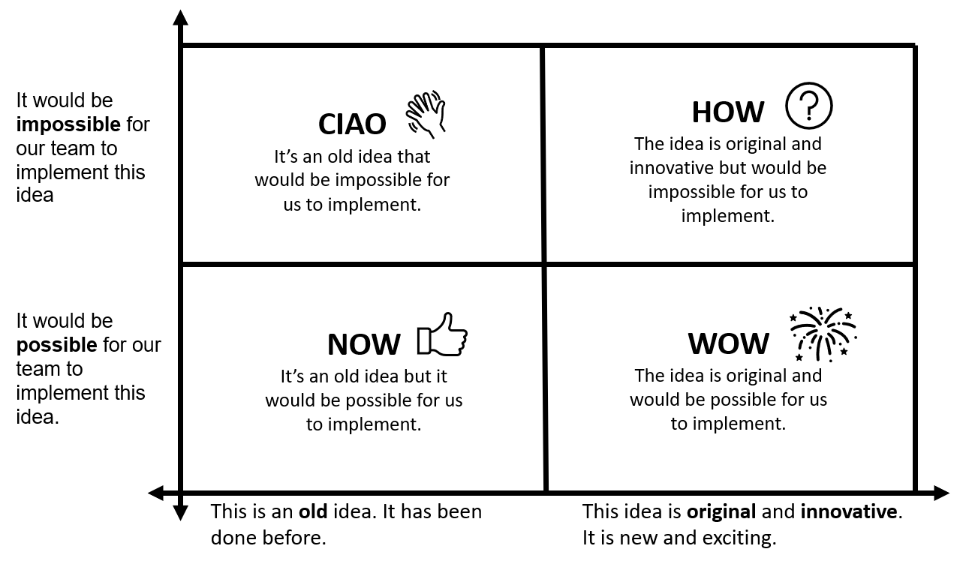

PART 4: DEVELOPING A PITCH
- Project teams critically reflect on how their idea would solve the problem. They discuss the connections between the problem, their idea and the desired future state.

- Provide each project team with an ‘Our Pitch’ worksheet. Explain how it can be used to develop a pitch for their idea. Explain each of the sections. Project teams use the worksheet to develop a ‘pitch’ for their idea, using the following sentence structure:
The problem is that____________________________________________.

We will______________________________________________________,

in order to____________________________________________________,

so that_______________________________________________________.

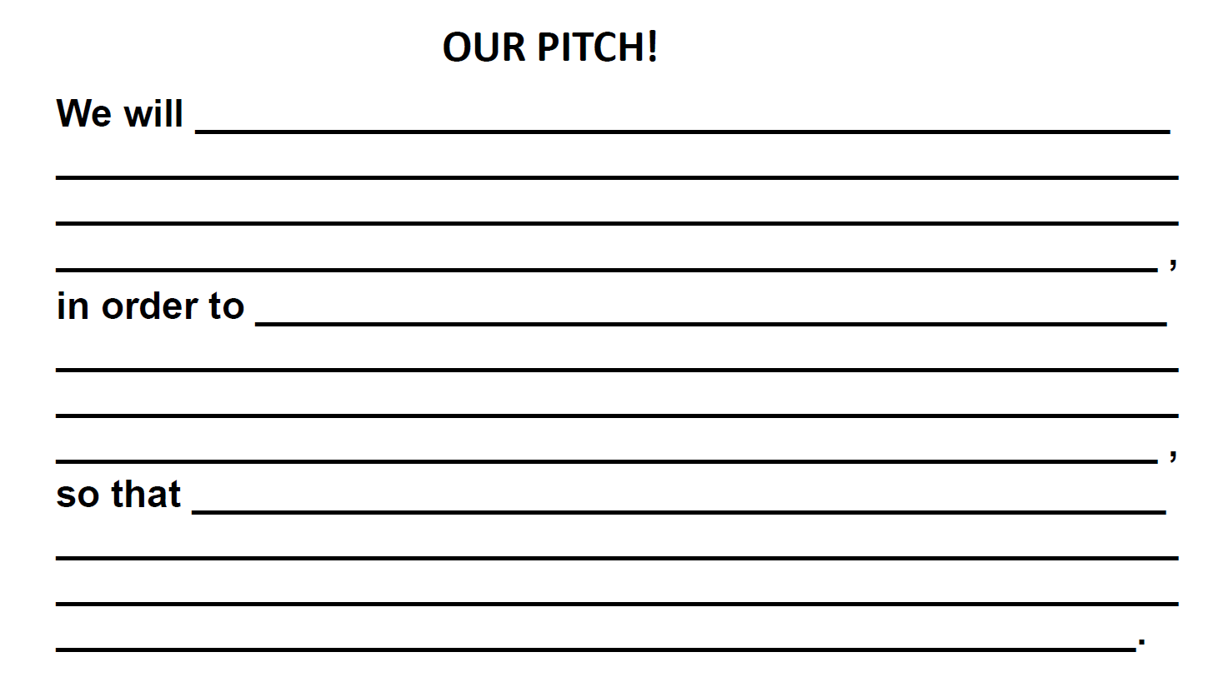

PART 5: CLASSROOM PRESENTATIONS
Each project team presents their pitch to the class. Students provide feedback on each pitch. The following questions can be used to facilitate discussion and elicit student feedback.

- What is the problem? Is this a real problem in our community?
- What is the desired future state?
- Can this idea help achieve the desired future state?

Project teams revise their pitch in response to feedback.

Students record their revised pitch in their learning journal.

MODULE 2: LOW FIDELITY PROTOTYPING (200 minutes)

LEARNING INTENTIONS
In this module, students will:
- discuss the benefits of low fidelity prototyping
- develop a low fidelity prototype using appropriate techniques and materials
- communicate their prototypes, evaluate design ideas, processes and solutions, and give and receive critical feedback
- use critical feedback to refine their low fidelity prototype

VICTORIAN CURRICULUM CONNECTIONS 2.0
GEOGRAPHY
Geographical knowledge and understanding
Management of places
- how places and environments are changed and managed by people (VC2HG6K01)
- the importance of sustainability to places and environments, including the custodial responsibility Aboriginal and Torres Strait Islander Peoples have for Country and Place and how it influences their sustainability practices (VC2HG6K04)
- the impacts of bushfires and other climate hazards on environments and communities, and how people and communities manage prevention, preparedness, response and recovery (VC2HG6K05)

Geographical skills
Concluding and decision-making
- develop evidence-based conclusions on the management of places using the concepts of place, interconnection, environment and sustainability
(VC2HG6S05)
- propose actions or responses to issues or challenges in land management and use criteria to assess the possible impacts (VC2HG6S06)

TECHNOLOGIES - DESIGN AND TECHNOLOGIES
Technologies contexts
Materials and specialisations
- explain how characteristics and properties of materials, systems, components and tools affect their use when producing designed solutions (VC2TDE6C04)

Creating designed solutions
Investigating and defining
- investigate needs or opportunities for designing, and the materials, components, tools and processes needed to create designed solutions (VC2TDE6D01)

Generating and designing
- generate, iterate and communicate design ideas, decisions and processes using technical terms and graphical representation techniques, using manual and digital tools (VC2TDE6D02)

Producing and implementing
- select, explain and use suitable materials, components, tools and techniques to safely make designed solutions (VC2TDE6D03)

Evaluating
- negotiate design criteria that address ethical considerations, including sustainability, to evaluate design ideas, processes and solutions (VC2TDE6D04)

Planning and managing
- develop project plans that include consideration of resources to individually and collaboratively make designed solutions (VC2TDE6D05)

ENGLISH
Level 5 – Literacy
Interacting with others
- use interaction skills including paraphrasing and questioning to clarify meaning, make connections to personal experience or to a text, and present and justify an opinion or idea (VC2E5LY01)
- deliver structured spoken and multimodal texts to an audience for a specific purpose, using features of voice (VC2E5LY02)

Level 6 – Literacy
Interacting with others
- use interaction skills and awareness of formality when paraphrasing, questioning, clarifying and interrogating ideas; developing and supporting arguments; and sharing and evaluating information, experiences and opinions (VC2E6LY01)
- deliver structured spoken and multimodal texts to an intended audience for a specific purpose, using appropriate features of voice (VC2E6LY02)

CRITICAL AND CREATIVE THINKING
Metacognition
- learning strategies suited to general and specific contexts, including different ways of identifying, expressing and organising key learning, and undertaking spaced practice (VC2CC6M01)
- thinking processes suited to different contexts and when and how to use them, including for problem-solving (VC2CC6M02)
- the use of criteria to identify and compare proposed solutions (VC2CC6M03)

PERSONAL AND SOCIAL CAPABILITY
Self-awareness and management
Emotional awareness and management
- when and how to use a range of peer support, self-regulation and other productive coping strategies; strategies for better understanding the feelings and needs of others and improving empathetic communication (VC2CP6S02)

MATERIALS AND RESOURCES
- Low Fidelity Prototyping Techniques Handout (one for each student)
- Materials, equipment and resources for producing low-fidelity prototypes (project dependent)

PART 1: LOW FIDELITY PROTOTYPING TECHNIQUES
- Introduce the students to the concepts of low fidelity and high fidelity prototyping. These resources provide good explanations:
- Getting Crafty with Low Fidelity Prototyping
- Low Fidelity vs. High Fidelity Prototyping - What's better?
- UX Prototyping Tutorial - What is a prototype?

- Provide each student with a copy of Low Fidelity Prototyping Techniques Handout (see below). Read through each technique encouraging the students to ask any questions.

LOW FIDELITY PROTOTYPING TECHNIQUES HANDOUT
Rough sketches and diagrams
Rough sketches and diagrams bring ideas out of your mind and into the world so they can be shared with other members of your project team for further discussion. You can easily change details as you are drawing. You can even tear it up and start again! All you need is a grey lead pencil, some paper and an eraser.
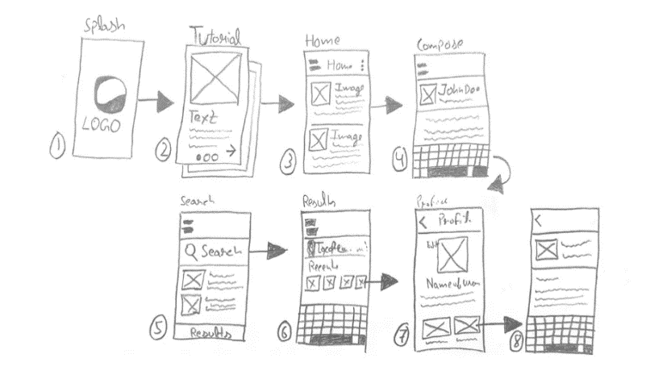
Paper interfaces
Paper interfaces are useful in the early stages of prototyping for digital products, such as websites, smartphone apps, and digital games. You can create paper interfaces by drawing and cutting out usable parts of the user interface, such as a text field or a dropdown menu, etc.). Paper prototypes help you to map out your product, identify problems and fix them early on the process. All you need are some markers, paper, scissors, and some glue or blu tack.
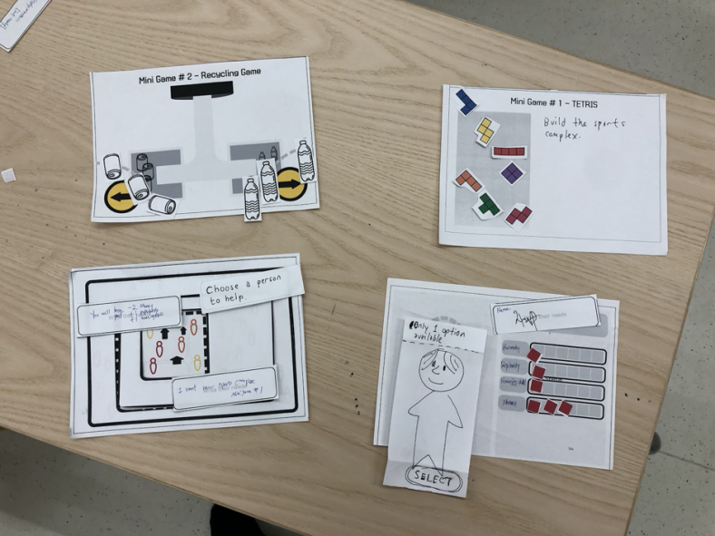

Storyboards
Storyboards are very useful for video projects because they allow you map out the dialogue and action for each scene. This saves a lot of time in the filming and editing process. It also helps you make sure that you have included all of the important information and that you have got your facts right! Your illustrations don’t need to be fancy - they just need to capture all the important elements in the scene.
Storyboards are also useful for planning interactive workshops and presentations because they help you to visualise what will happen at each stage.
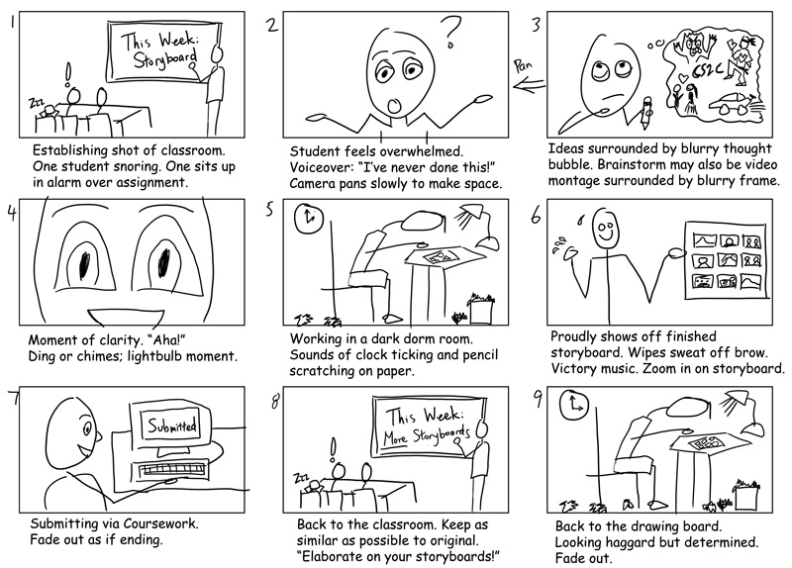
To make your storyboard you will need a storyboard template (see next page).

Storyboard Template


Physical models
Physical models are a good option for when the solution to the problem is a physical product. Physical models or ‘mock-ups’ can be created using a wide range of materials including paper, cardboard, plasticine, lego bricks, and foam. Physical models transform an intangible idea, or two-dimensional sketch, into a physical, three-dimensional object and sparks vibrant discussions about form and function.
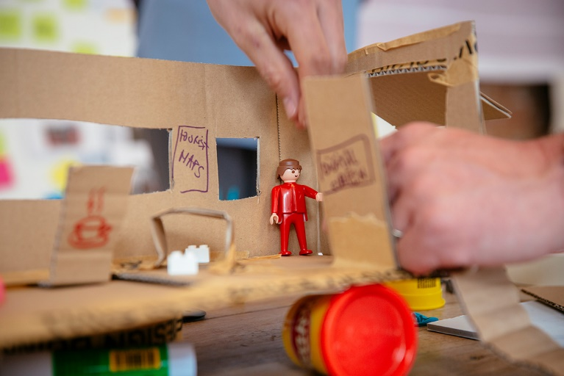

PART 2: DEVELOPING A LOW FIDELITY PROTOTYPE
- Allow a few minutes for the project teams to identify which Low Fidelity Prototyping technique (or combination of techniques) is best suited to developing their idea.

- When all of the project teams have chosen a technique, invite each team to share it with the class. Encourage the students to provide feedback on the suitability of the chosen techniques.

- Project teams can then develop low fidelity protypes of their idea. Encourage them to draw on the research they conducted during the Investigate phase. As they develop their prototypes, they may identify knowledge gaps and can conduct further research to address them.

PART 3: CLASSROOM PRESENTATIONS

- Project teams develop a short presentation to communicate their low fidelity prototype to the class.

- Students evaluate each other’s design ideas, processes and solutions and project teams use critical feedback to refine their prototype.

MODULE 3: INTERVIEWING EXPERTS (50 minutes)
NB: Students have already prepared for this module in INVESTIGATE Module 5 (i.e. they have identified an expert and planned/drafted an email.

LEARNING INTENTIONS
In this module, students will:
- prepare short presentation to explain their project to a subject matter expert
- develop interview questions to address knowledge gaps and uncertainties and receive feedback on their idea
- conduct an interview with an expert and record pertinent information
- use information and feedback collected in the interview to refine their low fidelity prototype

VICTORIAN CURRICULUM CONNECTIONS 2.0
GEOGRAPHY
Geographical knowledge and understanding
Management of places
- how places and environments are changed and managed by people (VC2HG6K01)
- the importance of sustainability to places and environments, including the custodial responsibility Aboriginal and Torres Strait Islander Peoples have for Country and Place and how it influences their sustainability practices (VC2HG6K04)
- the impacts of bushfires and other climate hazards on environments and communities, and how people and communities manage prevention, preparedness, response and recovery (VC2HG6K05)

Geographical skills
Geographical inquiry
- develop a range of geographical questions on how places are managed (VC2HG6S01)
- locate, collect and organise information and data from primary and secondary sources, including from fieldwork (VC2HG6S02)
- represent information and data collected using maps that conform to cartographic conventions, graphs, tables, sketches and other formats (VC2HG6S03)

Concluding and decision-making
- develop evidence-based conclusions on the management of places using the concepts of place, interconnection, environment and sustainability (VC2HG6S05)
- propose actions or responses to issues or challenges in land management and use criteria to assess the possible impacts (VC2HG6S06)

ENGLISH
Level 5 – Literacy
Interacting with others
- use interaction skills including paraphrasing and questioning to clarify meaning, make connections to personal experience or to a text, and present and justify an opinion or idea (VC2E5LY01)
- deliver structured spoken and multimodal texts to an audience for a specific purpose, using features of voice (VC2E5LY02)

Analysing, interpreting and evaluating
- use comprehension strategies, such as visualising, predicting, connecting, summarising, monitoring and questioning, to evaluate information and ideas to build literal and inferred meanings (VC2E5LY09)

Level 6 – Literacy
Interacting with others
- use interaction skills and awareness of formality when paraphrasing, questioning, clarifying and interrogating ideas; developing and supporting arguments; and sharing and evaluating information, experiences and opinions (VC2E6LY01)
- deliver structured spoken and multimodal texts to an intended audience for a specific purpose, using appropriate features of voice (VC2E6LY02)

Analysing, interpreting and evaluating
- use comprehension strategies, such as visualising, predicting, connecting, summarising, monitoring and questioning, and connect and compare ideas from a variety of sources to build literal and inferred meanings (VC2E6LY08)

SCIENCE
Science as Human endeavour
Use and influence of science
- scientific knowledge, skills and data can be used by individuals and communities to identify problems, consider responses and make decisions (VC2S6H02)

CRITICAL AND CREATIVE THINKING
Questions and possibilities
- the construction of questions for identifying and building understanding of information, possibilities, processes and activities (VC2CC6Q01)
- the importance of setting aside preconceptions; strategies for setting preconceptions aside when generating and evaluating alternative ideas and possibilities (VC2CC6Q02)
- an extended range of strategies to generate new ideas and possibilities including forming a link between different information sources (VC2CC6Q03)

PERSONAL AND SOCIAL CAPABILITY
Self-awareness and Management
Self-efficacy and sense of purpose
- what it means to be confident, adaptable and persistent; situations where these attributes are important; and what can and cannot be influenced through personal action (VC2CP6S04)

Social awareness and management
Relationships and diversity
- behaviours and attitudes that demonstrate sensitivity to individual, social and cultural differences, and why sensitivity to difference is important (VC2CP6O0)

MATERIALS AND RESOURCES
- Communications equipment/technology

PART 1: INTERVIEW PREPARATION

- Project teams review their problem statement, their pitch and their low fidelity prototype to prepare a short presentation (e.g. 3 mins) about their project and what they are hoping to achieve. This will ensure that the subject matter expert is able to provide relevant information and advice that is tailored to students’ needs and interests.

- Project teams can then develop a ‘Know/Want to know’ chart to identify knowledge gaps and formulate questions for their expert. They should also formulate questions to elicit expert feedback on their idea and their initial prototype.

- As a class, identify and practice interaction skills that can be used to keep the conversation moving, clarify meaning and demonstrate respect for their interviewee.

PART 2: CONDUCTING THE INTERVIEWS

- Project teams conduct interviews with their subject matter experts and record pertinent information and feedback.

- Encourage students to engage in a post-interview debrief to ensure that all pertinent information has been recorded.

NB: Students may audio or video record the interview if the interviewee provides their consent.

PART 3: REFINING LOW FIDELITY PROTOTYPES

- Project teams evaluate how the information and advice obtained from their subject matter expert can be used to improve their problem statement, their pitch, and their low fidelity prototype.

- Students make any necessary improvements before moving on to high-fidelity prototyping.

MODULE 4: HIGH FIDELITY PROTOTYPING (200 minutes +)

LEARNING INTENTIONS
In this module, students will:
- develop a project plan which outlines the production steps and resources needed to produce their high fidelity prototype and set milestones for production
- Co-create a rubric for assessing design processes and products (under development)
- produce a high fidelity prototype, documenting the design process as they progress
- present their high-fidelity protypes to the class and identity how they can share their prototypes with the wider school community.

VICTORIAN CURRICULUM CONNECTIONS 2.0
GEOGRAPHY
Geographical knowledge and understanding
Management of places
- how places and environments are changed and managed by people (VC2HG6K01)
- the importance of sustainability to places and environments, including the custodial responsibility Aboriginal and Torres Strait Islander Peoples have for Country and Place and how it influences their sustainability practices (VC2HG6K04)
- the impacts of bushfires and other climate hazards on environments and communities, and how people and communities manage prevention, preparedness, response and recovery (VC2HG6K05)

TECHNOLOGIES - DESIGN AND TECHNOLOGIES
Technologies contexts
Materials and specialisations
- explain how characteristics and properties of materials, systems, components and tools affect their use when producing designed solutions (VC2TDE6C04)

Creating designed solutions
Investigating and defining
- investigate needs or opportunities for designing, and the materials, components, tools and processes needed to create designed solutions (VC2TDE6D01)

Generating and designing
- generate, iterate and communicate design ideas, decisions and processes using technical terms and graphical representation techniques, using manual and digital tools (VC2TDE6D02)

Producing and implementing
- select, explain and use suitable materials, components, tools and techniques to safely make designed solutions (VC2TDE6D03)

Evaluating
- negotiate design criteria that address ethical considerations, including sustainability, to evaluate design ideas, processes and solutions (VC2TDE6D04)

Planning and managing
- develop project plans that include consideration of resources to individually and collaboratively make designed solutions (VC2TDE6D05)

CRITICAL AND CREATIVE THINKING
Metacognition
- learning strategies suited to general and specific contexts, including different ways of identifying, expressing and organising key learning, and undertaking spaced practice (VC2CC6M01)
- thinking processes suited to different contexts and when and how to use them, including for problem-solving (VC2CC6M02)
- the use of criteria to identify and compare proposed solutions (VC2CC6M03)

PERSONAL AND SOCIAL CAPABILITY
Self-awareness and management
Emotional awareness and management
- when and how to use a range of peer support, self-regulation and other productive coping strategies; strategies for better understanding the feelings and needs of others and improving empathetic communication (VC2CP6S02)

MATERIALS AND RESOURCES
- Scrumboards (digital or analogue)
- Materials, equipment and resources for producing high fidelity prototypes (project dependent)

PART 1: DEVELOPING A PROJECT PLAN
- Seated in their project teams, students discuss and identify the required production steps and tasks for producing their high fidelity prototype. Explain to the students that they might need to add extra steps or change course as they progress, but this initial project plan will help get them started. On a large sheet of paper, students can use sticky notes to map out the production steps and tasks and arrange them in a logical order.

- Introduce the students to the Scrumboard project management methodology and demonstrate how they can use it track the production of their high fidelity prototype. Students can use an analogue scrum board using a large sheet of poster paper and post it notes, or they can use one of the free online platforms such as Trello.

- Allow some time for the students to set up their project plan in a scrumboard. Project teams may wish to allocate specific tasks to particular team members, and this can also be indicated on the scrumboard. When students have set up their scrumboards, invite each project team to share the first few steps/tasks in their project plan.

- Students can then identify the materials, equipment or supplies they will need to produce their high fidelity prototype. Encourage students to make use of resources that a freely available at school or at home.

- To conclude this part of the module, review the characteristics of effective teams that students developed in Module 1: Part 4 – Identifying characteristics of an effective team.

PART 2: CO-CREATE A RUBRIC FOR ASSESSING DESIGN PROCESSES AND PRODUCTS
- Students co-create a multi-level rubric with success criteria that can be used to monitor their progress and assess their final products. The rubric can address the key learning outcomes in Design and Technologies, Science, and Personal and social capability listed under ‘Curriculum Connections’ for this module.

PART 3: PRODUCING A HIGH-FIDELITY PROTOTYPE
- Project teams procure the resources required to produce their solution and embark on the production of a high-fidelity prototype. They use their project plan and the assessment rubric to monitor and evaluate their progress and document their design process.

- Allow a couple of weeks for students to complete the production process. Students may wish to work on their projects outside of the allocated classroom sessions and this may in fact be necessary for some projects, depending on their scope and complexity.

- To monitor student progress, hold a ‘stand up meeting’ or ‘scrum’ at the beginning of each allocated classroom session. Allow a few minutes for the project teams to update their scrumboard and discuss the following three questions:

1. What have you achieved so far?
2. What will you do today?
3. Is anything blocking your progress?

When the project teams are ready, ask a spokesperson from each team to provide an update to the class with reference to the three questions.

NB: As students develop their high-fidelity prototypes, monitor their progress, and provide guidance and assistance as required. Students might like to reengage with their subject matter experts to obtain additional advice or feedback. Specialist teachers within the school may also be able to offer guidance and assistance to the project teams as they finalise their prototypes.

PART 4: CLASSROOM PRESENTATIONS
- When the project teams have completed their high fidelity protypes, they can share them with the rest of the class. Encourage the students to engage with each other’s prototypes and provide each other with suggestions for any final improvements.

- Once students have had an opportunity to engage with each other’s prototypes, facilitate a class discussion about the best ways to share their prototypes with the wider school community (e.g. films could be screened at school assemblies, websites could be shared in the school newsletter, posters or brochures could be displayed around the school).

MODULE 5: STUDENT LEARNING SHOWCASE
NB: The style and format of the student learning showcase is entirely up to the school. The activities outlined here are suggestions only.

LEARNING INTENTIONS
In this module, students will:
- showcase their prototypes and their design process to the school community
- use the co-created assessment rubric to review their learning

VICTORIAN CURRICULUM CONNECTIONS 2.0
GEOGRAPHY
Geographical knowledge and understanding
Management of places
- how places and environments are changed and managed by people (VC2HG6K01)
- the importance of sustainability to places and environments, including the custodial responsibility Aboriginal and Torres Strait Islander Peoples have for Country and Place and how it influences their sustainability practices (VC2HG6K04)
- the impacts of bushfires and other climate hazards on environments and communities, and how people and communities manage prevention, preparedness, response and recovery (VC2HG6K05)

TECHNOLOGIES - DESIGN AND TECHNOLOGIES
Creating designed solutions
Investigating and defining
- investigate needs or opportunities for designing, and the materials, components, tools and processes needed to create designed solutions (VC2TDE6D01)

Generating and designing
- generate, iterate and communicate design ideas, decisions and processes using technical terms and graphical representation techniques, using manual and digital tools (VC2TDE6D02)

Producing and implementing
- select, explain and use suitable materials, components, tools and techniques to safely make designed solutions (VC2TDE6D03)

Evaluating
- negotiate design criteria that address ethical considerations, including sustainability, to evaluate design ideas, processes and solutions (VC2TDE6D04)

ENGLISH
Level 5 – Literacy
Interacting with others
- use interaction skills including paraphrasing and questioning to clarify meaning, make connections to personal experience or to a text, and present and justify an opinion or idea (VC2E5LY01)
- deliver structured spoken and multimodal texts to an audience for a specific purpose, using features of voice (VC2E5LY02)

Level 6 – Literacy
Interacting with others
- use interaction skills and awareness of formality when paraphrasing, questioning, clarifying and interrogating ideas; developing and supporting arguments; and sharing and evaluating information, experiences and opinions (VC2E6LY01)
- deliver structured spoken and multimodal texts to an intended audience for a specific purpose, using appropriate features of voice (VC2E6LY02)

CRITICAL AND CREATIVE THINKING
Metacognition
- learning strategies suited to general and specific contexts, including different ways of identifying, expressing and organising key learning, and undertaking spaced practice (VC2CC6M01)
- thinking processes suited to different contexts and when and how to use them, including for problem-solving (VC2CC6M02)
- the use of criteria to identify and compare proposed solutions (VC2CC6M03)

PERSONAL AND SOCIAL CAPABILITY
Self-awareness and management
Emotional awareness and management
- when and how to use a range of peer support, self-regulation and other productive coping strategies; strategies for better understanding the feelings and needs of others and improving empathetic communication (VC2CP6S02)

PART 1: SHOWCASE PREPARATION
As noted above the style and format of the showcase is entirely up to the school however, the following activities have proven successful in the pilot program:
- Have each project team set up their own exhibition stand which displays their prototype and and other learning artifacts that help to tell the story of the learning journey
- Allow time for students to produce marketing materials such as banners, business cards, QR codes that link to digital products, and name badges.
- Invite local emergency management staff and volunteers (e.g. Council staff, the local CFA brigade), parents, and subject matter experts who have supported the students in their learning journey.
- Engage students in decision-making about how the event will run – this provides them with a sense of ownership and control, which in turn helps to create a space where they feel confident to share their work and engage with adults.

PART 2: THE SHOWCASE EVENT

Students host a showcase event to share their projects with their school community.

A good example of a student showcase can be found here Schools in Fire Country Practice Note 2.4 - The student showcase.pdf

