Child's Name
Evacuation Plan

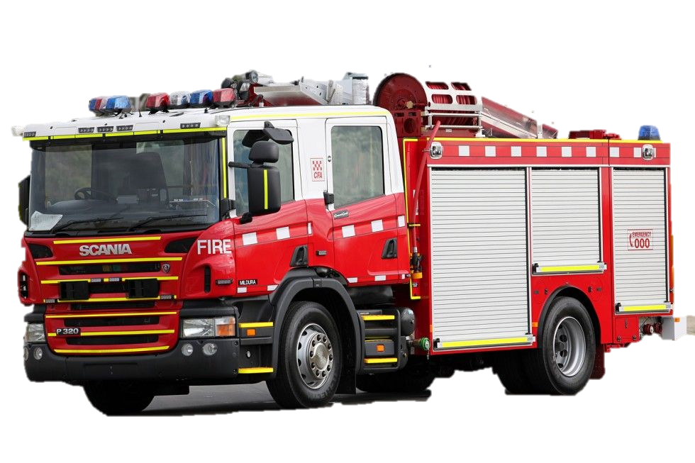


S.P.A.R.K
Supporting People with Autism Resource Kit



Today seems like every other normal day at school for Child's Name.
Child's Pronoun is busy working on the tasks Child's Pronoun teacher has set out for Child's Pronoun
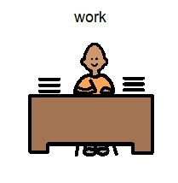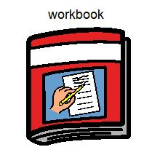
1

While Child's Name is hard at work, the emergency fire alarm shrieks out through the classroom speaker.

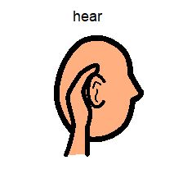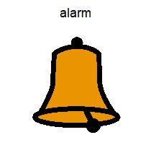

2
3
3
When this alarm sounds it can mean a few things. The school could be practising an evacuation drill, or there is an actual emergency and the school needs to begin an evacuation. This is the time when it is very important for Child's Name to stop Child's Pronoun work.

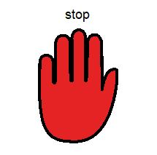
4
5
5
Child's Name stops what Child's Pronoun is doing and looks to Teacher's Name for instructions on what to do next. Child's Name and Child's Pronoun classmates remain nice and calm, ready to evacuate the building when Teacher's Name tells them to.

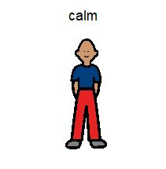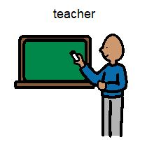
6
7
7
On Teacher's Name instruction, Child's Name lines up at the door with Child's Pronoun class. Teacher's Name checks the classroom to ensure all the students are lined up at the door.
Child's Name along with everybody else is now ready to leave the classroom and follow Teacher's Name to the evacuation area.

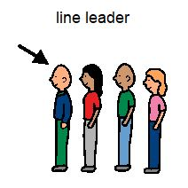
8
9
10
The emergency alarm in the classroom continues to make a loud noise for a long time. This is normal. It gives everybody in the school a chance to hear the alarm and get themselves ready to evacuate the school building

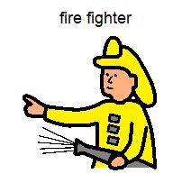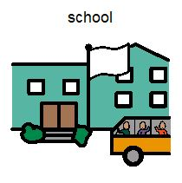
112

Remaining in a nice straight line, Teacher's Name leads Child's Name and the other students out to the evacuation area, away from the problem. Everybody is wondering what might be happening. It is very important to remain at the evacuation area, away from possible danger.

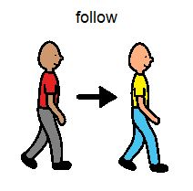
12
13
Teacher's Name asks everybody to sit quietly in a nice neat line. All of the other grades are lining up as well.
This is when Teacher's Name marks the roll so Teacher's Pronoun knows Teacher's Pronoun students are safe and away from any danger

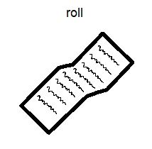
14
15
Whenever there is an emergency within a school, the local fire brigade are alerted. Firefighters arrive in fire trucks, stocked with all the equipment they need in order to help with the emergency and keep everyone safe.

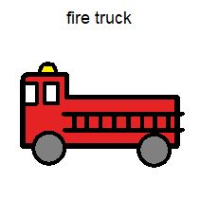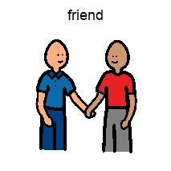
16
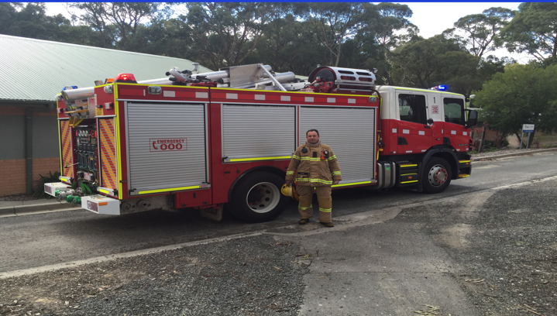
17
Child's Name may see some of these courgeous helpers. They dress in high visibility uniforms so they can be recognised easily in an emergncy.
Many different people volunteer to be firefighters, they could be a mum or dad or an aunty or uncle.

18
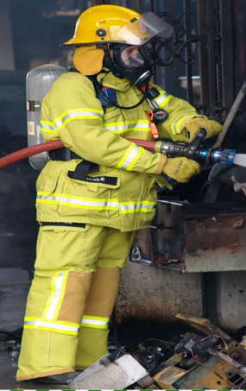

19
The firefighters will let Teachers Name know as soon as it is safe for Child's Name and Child's Pronoun classmates to head back to class. Once Child's Name returns to Child's Pronoun classroom, Child's Pronoun can get back to Child's Pronoun work.
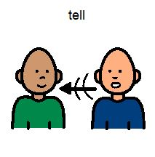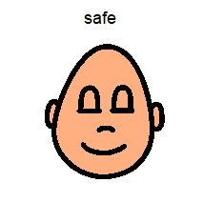
200

The ‘S.P.A.R.K’ book and resource kit were especially created for children with special needs to aid in a positive and effective evacuation in case of an emergency at school. We hope it proves a valuable and useful tool for many children who may struggle with the challenges of uncertain circumstances changing their daily routine.

S.P.A.R.K in partnership with CFA

Hailey Vassallo
Barb Brokenshire
John Dallimore
Mayer-Johnson
2100 Wharton Street
Suite 4000
Pittsburgh, PA 15203
Phone: 1 (800) 588 4548
Fax: 1 (800) 585 6260
www.mayer-johnson.usa@dynavoxtech.com
Terrie White

