Child's Name
Evacuation Plan

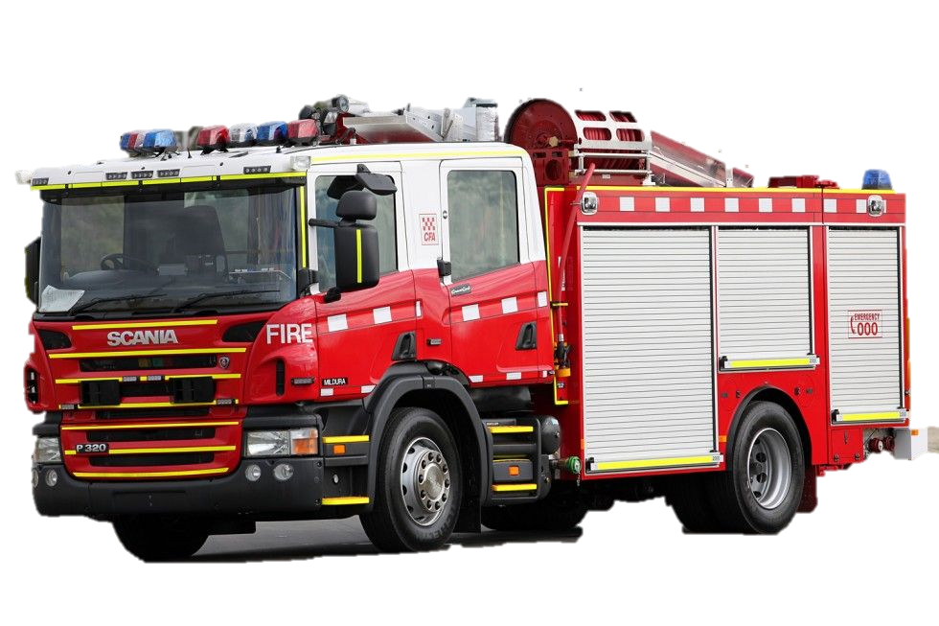


S.P.A.R.K
Supporting People with Autism Resource Kit



Today seems like every other normal day at school for Child's Name. Child's Pronoun is busy working on the tasks Child's Pronoun teacher has set out for Child's Pronoun
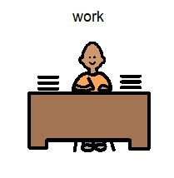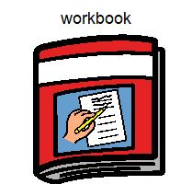
1

Suddenly, there is an alarm sounding from the classroom speaker.
It is the emergency alarm, and it is not stopping.

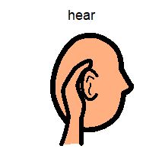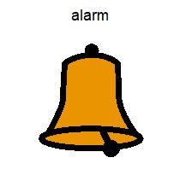

2
3
3
When this alarm sounds it can mean a few things. The school could be practising an evacuation drill, or there is an actual emergency and the school needs to begin an evacuation. This is the time when it is very important for Child's Name to stop Child's Pronoun work.

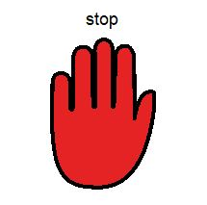
4
5
5
Child's Name stops what Child's Pronoun is doing and looks to Teacher's Name for instructions on what to do next. Child's Name and Child's Pronoun classmates remains nice and calm.

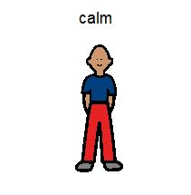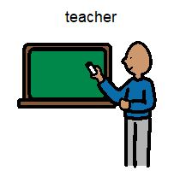
6
7
7
Teacher's Name asks Child's Name and Child's Pronoun classmates to line up at the door. Everybody is getting ready to leave the classroom and follow Teacher's Name to the evacuation area.

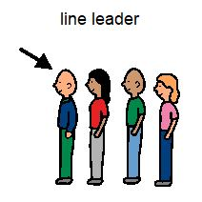
8
9
10
The alarm in the classroom continues to make a loud noise. This is normal. It gives everybody a chance to get themselves ready to evacuate the school building.

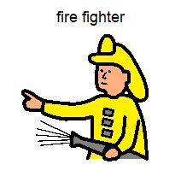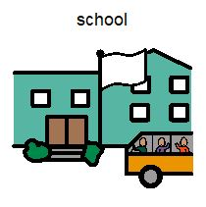
112

Teacher's Name leads all the students out to the evacuation area. Child's Name and Child's Pronoun classmates wonder what might be happening and where the problem might be.

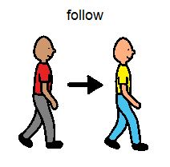
12
13
When they reach the evacuation area Teacher's Name asks everybody to sit quietly in a nice neat line. All of the other grades are lining up too. This is when Teacher's Name marks the roll.
This is done so Teacher's Pronoun knows her students are safe and away from any danger

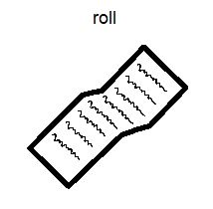
14
15
Whenever there is an emergency at a school, the local fire brigade are alerted. Firefighters arrive in fire trucks to help with the emergency and help keep everyone safe.

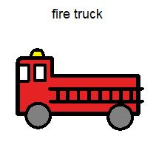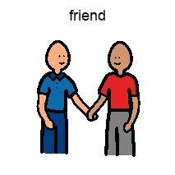
16
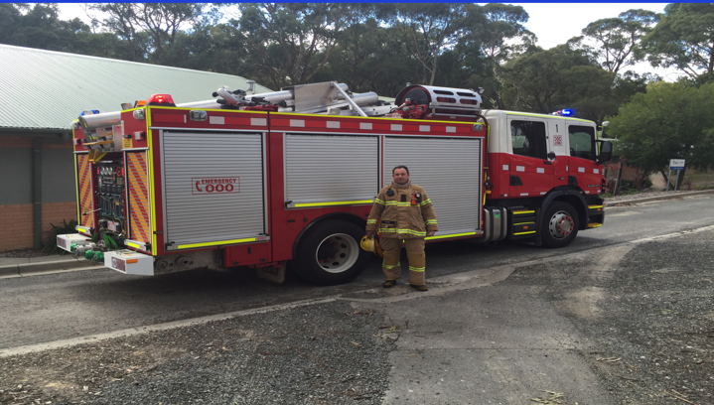
17
Child's Name may see some of these courgeous helpers. They arrive to help keep everybody safe. Their high visibility uniforms make it easy to recognise them.

18
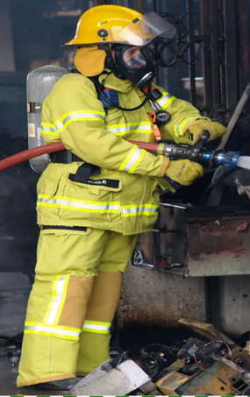

19
The firefighters will let Teachers Name know as soon as it is safe for Child's Name and Child's Pronoun classmates to head back to class. Once Child's Name returns to Child's Pronoun classroom, Child's Pronoun can get back to Child's Pronoun work.
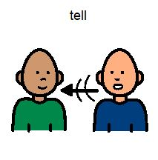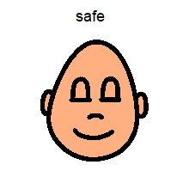
200

The ‘S.P.A.R.K’ book and resource kit were especially created for children with special needs to aid in a positive and effective evacuation in case of an emergency at school. We hope it proves a valuable and useful tool for many children who may struggle with the challenges of uncertain circumstances changing their daily routine.

S.P.A.R.K in partnership with CFA

Hailey Vassallo
Barb Brokenshire
John Dallimore
Mayer-Johnson
2100 Wharton Street
Suite 4000
Pittsburgh, PA 15203
Phone: 1 (800) 588 4548
Fax: 1 (800) 585 6260
www.mayer-johnson.usa@dynavoxtech.com
Terrie White

