Child's Name
Evacuation Plan

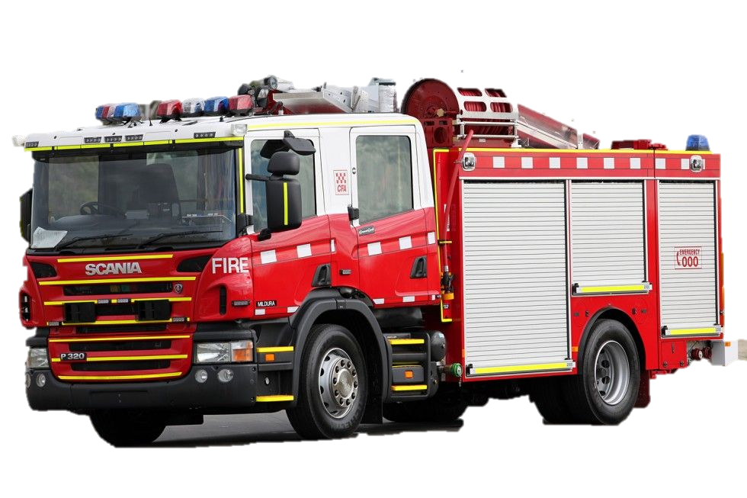


S.P.A.R.K
Supporting People with Autism Resource Kit



Child's Name is doing Child's Pronoun work in Child's Pronoun classroom.

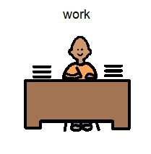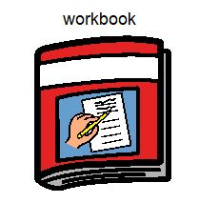
1

Ooh! That is a very loud sound! It is the emergency alarm coming from the speaker.

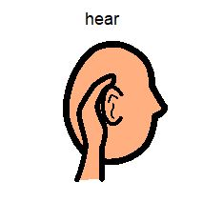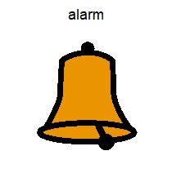

2
3
3
It is time for Child's Name to stop Child's Pronoun work.

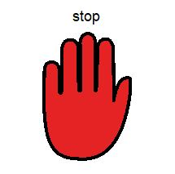
4
5
5
It is time for Child's Name to remain calm and listen
to Child's Pronoun teacher.

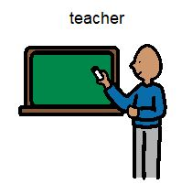
6
7
7
Child's Name now lines up at the door with
Child's Pronoun classmates.

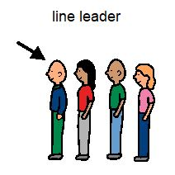
8
9
10
The alarm is still making a loud noise
But that is OK, just telling the firefighters to come to our school.

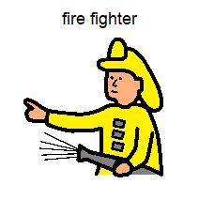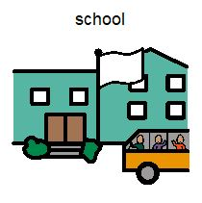
112

Now it is time for Child's Name to follow Teacher's Name out to the evacuation area.

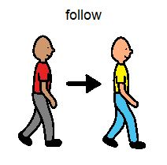
12
13
When Child's Name and Child's Pronoun classmates get to the evacuation area, they must wait quietly.
Teachers Name will mark the roll.

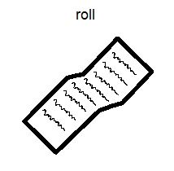
14
15
Child's Name may see fire trucks arrive.
Child's Pronoun may even see some of these courageous helpers.

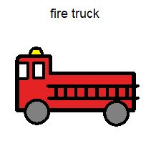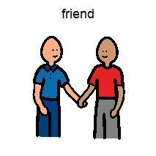
16
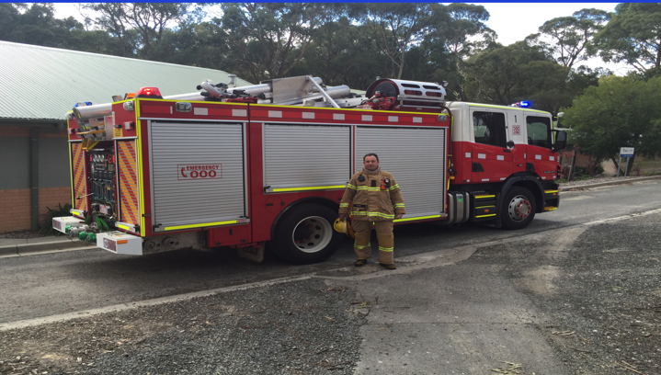
17
This is what the firefighters look like. It is important to remember they are friendly and are here to help.

18
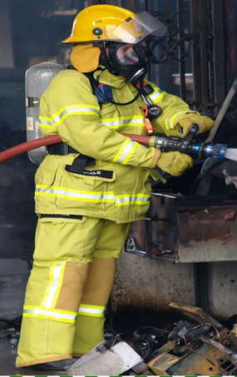

19
The firefighters will let Teachers Name know when it is safe for Child's Name and Child's Pronoun classmates to go back to the classroom.
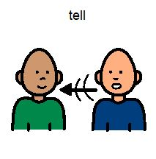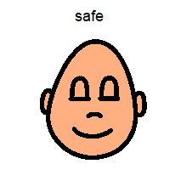
200

The ‘S.P.A.R.K’ book and resource kit were especially created for children with special needs to aid in a positive and effective evacuation in case of an emergency at school. We hope it proves a valuable and useful tool for many children who may struggle with the challenges of uncertain circumstances changing their daily routine.

S.P.A.R.K in partnership with CFA

Hailey Vassallo
Barb Brokenshire
John Dallimore
Mayer-Johnson
2100 Wharton Street
Suite 4000
Pittsburgh, PA 15203
Phone: 1 (800) 588 4548
Fax: 1 (800) 585 6260
www.mayer-johnson.usa@dynavoxtech.com
Terrie White

