Fire Ready Guide for Community Workers
  - How to support your clients with their fire preparation and planning

Acknowledgement of Country
  - CFA would like to acknowledge the Traditional Owners of the land across Victoria and pay our deep respect to elders past, present and emerging.


Contents
Purpose of this guide 5
Why is planning for fire important? 6
Your role as a service provider 7
CFA training 8
Commonly asked questions about fire safety 9
Talking to your client about their Bushfire Survival Plan 22
Clients who choose not to leave 25
Making this all work 26
Referral pathway 27
Contact CFA 28

CFA would like to acknowledge and thank the contribution and assistance of Associate Professor Michelle Villenueve from The University of Sydney, Centre for Disability Research and Policy in relation to the Person-Centred Emergency Preparedness Framework.

Purpose of this guide
  - CFA knows that as essential community service providers, you play an important role in the health and wellbeing of your clients.
You provide support to people with their day to day living, and often are a trusted source of information with a strong understanding of your client’s needs.
It is for this reason that CFA needs your help to reach those who are at greatest risk and live in fire prone areas. This guide has been developed to help support you to care for those who are at greatest risk of fire.

Someone at greatest risk
Is defined as individuals who have the potential to be adversely affected by a bushfire and who, because of the circumstances in their everyday lives, require significant and coordinated priority intervention, response and support from a variety of government and non-government organisations and the broader community for their safety.

Fire refers to
Fire that could threaten your client’s home and life based on living close to grassland, bushland or coastal scrub. This includes bushfires, grassfires and scrub fires.
This does not include house or structure fires.
If you would like to access information on supporting your client to prepare for house fires, visit CFA’s website www.cfa.vic.gov.au/homefire or download CFA’s Home Fire Safety Book.
A Bushfire Survival Plan template has been developed for your clients to help them create their plan. This can be found on CFA’s website www.cfa.vic.gov.au/leaveearly

Why is planning for fire important?
  - It is important that people who live in high fire risk areas have a fire plan.
This is especially true for people with a chronic or acute health condition, physical and/or cognitive disability or those of older age. This can also be true for people who are socially isolated.
These people can be at greatest risk as they can find it difficult to leave their homes and may face significant barriers to attending CFA community meetings and accessing fire safety information.
44% of people who died in the 2009 Victorian Black Saturday fires were vulnerable. - Statistic from the Victorian Bushfires Royal Commission.
CFA needs your help to reach those who are at greatest risk living in fire prone areas.

Your role as a service provider
  - The role of service providers is vitally important and CFA recognises how hard you work to help keep your clients safe and well.

With some help from CFA, you can prompt and support your clients to prepare their Bushfire Survival Plan. In fact, many of you may already be doing this. Your client’s survival may depend on the people who provide support to them having a basic understanding of bushfire survival planning and assisting them to think through their options.
Your clients are likely to face barriers, such as limited capacity, skills or resources, to defend their home during a fire. With help from CFA, you can develop your skills and knowledge to support your clients in developing a written plan to leave early.
This guide is intended for people who work or volunteer in the community and social services sector and parts of the health sector. It aims to help those who visit clients and patients in their home, such as:
- Disability support workers
- Aged care support workers
- Case managers
- Mental health support workers
- Family and friends caring for people in their homes
- Occupational therapists
- A range of other in-home support providers including nursing services and some general practitioners.
This guide has been designed for those who have completed the CFA face-to-face or online training.

CFA training
  - CFA has developed bushfire training to help you and your organisation. This guide complements the CFA training.
If you have not already completed the training, it can be accessed in two ways:
- Book a face-to-face group session for your workplace through your local CFA
- Do the e-learning modules on CFA’s website www.cfa.vic.gov.au/workers
CFA realises there are different roles for people providing home care in the community. The training is designed to help you support your client to prepare for and plan for bushfire. There are referral pathways at the end of this guide to help you do this.
There are two e-learning modules to help you learn about bushfire and plan for bushfire with your clients:
- Bushfire Safety for Workers – Summer Safe Travel
- Bushfire Planning – How to support your clients
Each training option complements the other, you can do one or both.

Commonly asked questions about fire safety
  - CFA knows there is a lot of information about fire safety around. These answers to commonly asked questions will help you support your client with their fire preparation and planning.

What are Fire Danger Ratings and how are they used?
Fire Danger Ratings help you understand how dangerous a fire would be if one started on a given day. The higher the rating the more dangerous a fire would be. Fire Danger Ratings alert you to the fire risk so action can be taken before a fire starts and there is any danger.
There are recommended actions for each level of Fire Danger Rating below. Many main roads also have Fire Danger Rating signs and so might the local fire station.
Fire Danger Rating | What to expect
Code Red | These are the worst conditions for a bush or grassfire.
Extreme | If a fire starts and takes hold, it will be uncontrollable, unpredictable and fast moving. Spot fires will start, move quickly and come from many directions.
Severe | If a fire starts and takes hold, it may be uncontrollable.
Very High | If a fire starts, it can most likely be controlled in these conditions and homes can provide safety
High | If a fire starts, it can most likely be controlled in these conditions and homes can provide safety
Low-Moderate | If a fire starts, it can most likely be controlled in these conditions and homes can provide safety
These ratings are not a predictor of how likely it is that there will be a fire, but rather how dangerous one would be if it started. Your client can use the Fire Danger Ratings as a trigger to enact their Bushfire Survival Plan.

How does my client find out what Fire Danger Rating it is?
Fire Danger Ratings are calculated for each Fire Weather District and are provided as a four-day forecast on the CFA website. It is important to make a habit of checking the Fire Danger Rating daily in case the forecast changes. Your client can use the following sources of information to find out what the daily Fire Danger Rating is:
- Newspapers
- CFA
- Local news – ABC Local Radio, commercial and designated community radio stations or Sky News TV
- VicEmergency website or app.
It is important to rely on multiple sources of reliable information to stay informed. If it is easier, your client can call the VicEmergency hotline free call 1800 226 226.

What are Fire Weather Districts?
There are nine Fire Weather Districts in Victoria.
Districts can have different Fire Danger Ratings depending on the weather and other factors. Your client needs to know which Fire Weather District they live in.
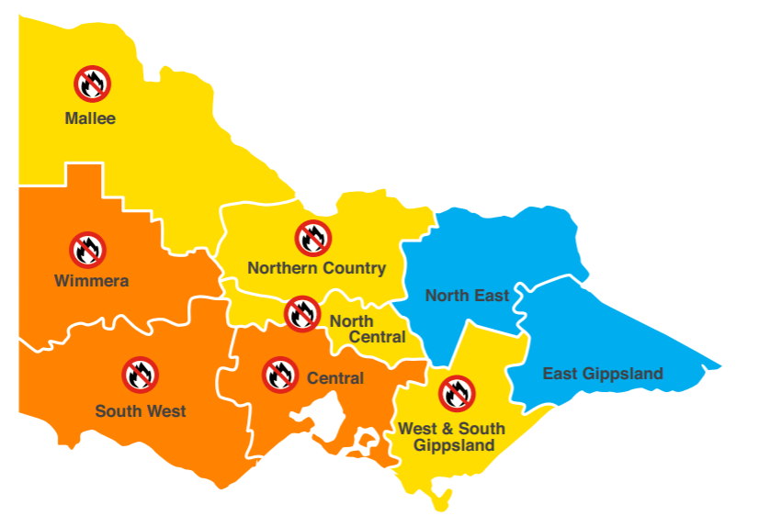

What is a Total Fire Ban?
There are laws about lighting fires outside over summer in Victoria. Some days that are very hot, dry and windy will be Total Fire Ban days. A Total Fire Ban (TFB) sets legal restrictions on what activities are allowed for that day. It aims to reduce fires starting.
TFBs are declared by Fire Weather District or can be declared for the whole state of Victoria.
On these days no fires are allowed outside. This ban includes the use of campfires, solid fuel barbecues and incinerators. You are also not allowed to use machinery that can make sparks such as welding, grinding, soldering or gas cutting. You can only use gas BBQs if you follow certain rules.
You can find more information of what you can or can’t do in the Can I or Can’t I? resource on the CFA website www.cfa.vic.gov.au/can

Will a fire truck come to my client’s house during a bushfire?
It is unlikely. During a major bushfire you must not rely on a fire truck coming to your home.
CFA only has a set number of trucks and there are not enough for every house or property. Often fire trucks will be busy fighting the main part of the fire.

What types of warnings will my client receive?
Below are all the different types of warning messages that can be issued in an emergency. Your client can find out this information from multiple sources. See page 16 of this resource for sources of information.
Warning levels can be issued in any order. The first warning issued could be an Emergency Waring.

Warning levels: There are three different levels
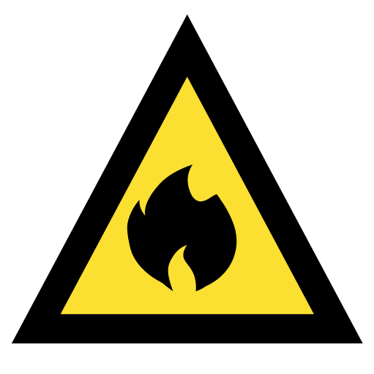 | Advice | There is a fire occurring in the area. You need to get information and monitor conditions.
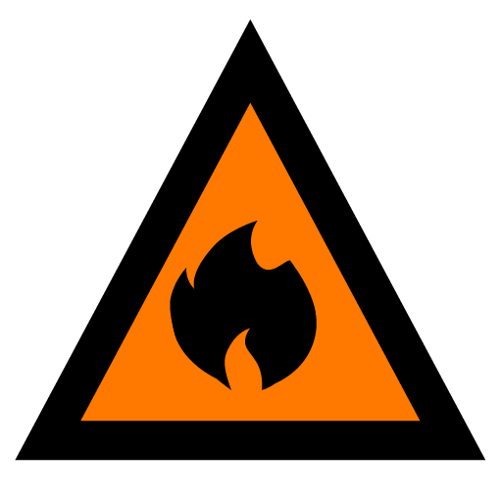 | Watch and Act | A fire is developing nearby.  You need to take action now to protect yourself and others.
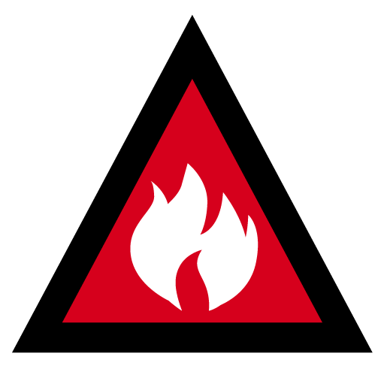 | Emergency Warning | You are in immediate danger and need to act now. You will be impacted by fire.

Additional messages that may be issued.
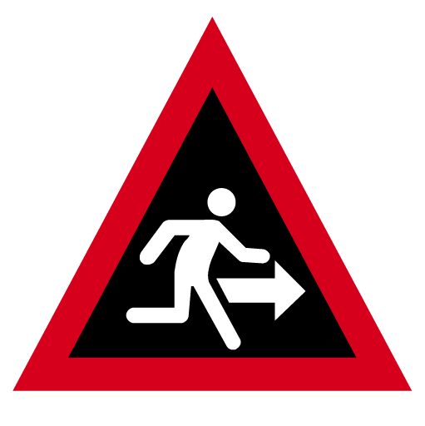 | Prepare to evacuate / evacuate now | An evacuation is recommended or procedures are in place to evacuate.
 | Community information | A newsletter containing updated for communities affected by an emergency. It can also be used as a notification that and incident has occurred but there is no threat to community.

Will my client be evacuated or told when to leave?
This is unlikely and not guaranteed. Victoria Police is the lead agency in an evacuation.
A Prepare to Evacuate or Evacuate Now are issued in some situations. This does not mean someone will come to get you or tell you to leave. You should NOT rely on receiving one of these warnings.
A Prepare to Evacuate or Evacuate Now depends on several factors, including:
- safety considerations including how long before the fire reaches the area that is being evacuated
- the location and type of fire
- access routes and the local environment.
There may be some circumstances where a safe evacuation is not possible and your client will be told it’s too late to leave. They may need to seek another shelter option including staying inside or going to a nearby well-prepared property.
Sheltering in an unprepared house without active defence is extremely dangerous.
The safest option is always to leave the day before or early in the morning.
In fast-moving emergencies your client will not always receive an official warning or an evacuation message.

My client is on the Vulnerable Persons Register, will they be evacuated?
Vulnerable Persons Registers are local lists, held by the local Council, of people who meet a strict criterion of vulnerability and are at risk of bushfire or flood.
If your client is on the Vulnerable Persons Register then Victoria Police may be able to evacuate your client in an emergency. But it is not guaranteed.
This is because:
- there may not be enough time, particularly with fast moving fires
- there may not be police close enough
- police may not have the right vehicle to safely move your client.
It is essential that your client has a plan in place to relocate the day before or early in the morning, before a bushfire starts or threatens.

What does it mean to leave early?
Leaving early means leaving before a bushfire has even started. It means leaving long before a fire could impact. This is the safest option.
The decision to leave is usually based on the Fire Danger Ratings but should take into consideration your client’s personal circumstances, specific needs and barriers.
Example of what it means to leave early
Joan is an 80-year-old woman who is blind and lives alone in a high fire risk area.
Due to a recent hip replacement, Joan also has limited mobility. Joan’s plan is to leave her house early in the morning on a Code Red or Extreme day.
Her daughter, who lives a few suburbs away will pick her up at 8.00am before she starts work and take her to her house, closer to the city.
Joan will stay at her daughter’s house until the weather changes and the Fire Danger Rating reduces.

What if my client is at risk of grassfire?
Grassfires can start and spread quickly. Grassfires can pose different risks depending on the area and the amount of surrounding grassland. Because grass is small and fine, it is easier and quicker to burn.
If your client lives near grassland, they should plan and prepare for grassfire and understand the risk.
The safest place to be on high fire risk days is well away from the threat.

Grassfires – rural
- If your client lives in a rural area with a lot of surrounding grassland, the threat grassfire poses could be greater.
- Grassfires can start earlier in the day than bushfires, because grass dries out more quickly when temperatures are high.
- The taller and drier the grass, the more intensely it will burn.
- Grassfires can travel up to 25km per hour and pulse even faster over short distances.
- Your client needs to shelter in their home to protect themselves from a rural grassfire. A well prepared home can provide protection from radiant heat.

Grassfires – near cities and towns
If your client lives near or backs onto grassland there are some simple things they can do to improve their safety.
- If your client lives next to grassland and a grassfire starts, they should move at least two streets back from the fire.
- If your client lives two or three streets away from grassland and a grassfire starts, they should stay where they are. Grassfires are unlikely to spread into built up areas.
- Your client should never drive or travel if they can see smoke or fire in an urban area. Thick smoke will make it hard to see and traffic jams and accidents are likely

Where should be client go?
Evacuation centres or relief centres will only open when there is a bushfire emergency. Your client needs to find somewhere to go that suits their needs and where they feel comfortable.
On high fire risk days your client could go:
- to friends or family who live in low fire risk regional or urban centres
- to local air-conditioned and serviced centres such as a Senior Citizens Club, library, shopping centre or Place of Worship away from high risk areas
- to a respite centre or other care facility away from high fire risk areas.
CFA recommends that if you plan to leave a high fire risk area on a day of significant fire danger, you should do so the night before or early in the day.
Last-minute decisions to relocate when a fire has already started are highly dangerous. It is particularly dangerous for people that are unable to leave without support from others.

How will my client know if there is a fire in the area?
If your client does not intend to leave early, then they need to work out when they will leave. For many people, this means leaving once they are aware of a fire in their area, but this is not a safe option to leaving early.
Leaving late is the most dangerous option and poses the largest threat to life.
Many of your clients will face barriers to leaving quickly. This makes good planning and leaving before the threat of a fire essential.
It is important that your client remains connected to current and reliable emergency advice.

On a day rated as Severe, Extreme or Code Red your clients can stay informed through:
- The VicEmergency App on their phone or tablet. They can set a watch zone on the app for a certain radius around their house. The app is designed to alert them with a notification if a fire starts close by.
- Listening to ABC Radio or a local emergency broadcaster.
- Monitoring CFA’s Twitter (@CFA_Updates) and Facebook page (facebook.com/cfavic).
- Monitoring the VicEmergency Website (www.emergency.vic.gov.au).
- Calling the VicEmergency Hotline 1800 226 226. Your client can also contact VicEmergency through the National Relay Service 1800 555 677 or the Translating and Interpreting Service 131 450 if they need.
- Watching Sky News TV.
- Using their eyes, ears and nose. Being alert to signs of fire in the area.
Waiting to see what will happen can be very dangerous as fires can move very quickly, with spot fires starting new fires ahead of the main fire. Your client needs to be prepared to leave if there is a fire in their area.

What transport options are available for my client?
Transport options include:
- Assistance from family or friends in a personal vehicle
- Public transport
- Taxis or other rise share options
- Accessible transport options locally
If your client does not have their own car, ask them how they plan to leave. If they are relying on a family member or friend, it is important to remind your client to double check the day before. It’s very important that everyone involved in your client’s Bushfire Survival Plan has a copy and agrees to it.
Depending on where your client lives and how isolated they are may mean there are very few public transport options. CFA understands that for some people, organising transport can be particularly challenging. Especially as there are often costs involved. Have these conversations with your client to help them find a suitable solution.
Check to see if there are local community transport options that can be accessed through the local Council or community groups.

What should my client take?
Your client should have an emergency kit already packed and stored somewhere easy to get to in their home. The emergency kit can include items like:
• change of clothes and toiletries
• identification and important documents such as photo ID, passport, insurance policies or will
• non perishable food and bottled water including pet food if needed.
There are also other items your client will need to take with them but cannot pack ahead of time. This can include items like:
• personal items (money, keys, glasses, jewellery)
• mobility aids
• assistive technology devices, mobile phone and chargers • communication aids
• medical equipment
• medications and prescriptions.
Ask your client what is most precious to them. They may want to take special photographs or memorabilia. If they have a lot of extra things to take, ask them if they could store this offsite over summer in a low fire risk location. Perhaps friends or family could store these items so that they’re safe.
If your client has not already registered for My Health Record, encourage them to do so.
My Health Record brings all of your client’s health details to the one place. This will make it easier to access things like prescriptions in times of an emergency. Visit www.myhealthrecord.gov.au

What if my client has pets or assistance animals?
Your client may have pets (including assistance animals), and they are an important part of their lives. Some people decide not to leave because they do not want to leave their pets.
So, pets need to be considered in planning where to go, how to get there, what to take and what to do with them.
You can access detailed advice about pets and bushfires from CFA’s website www.cfa.vic.gov.au/pets.

Does my client have to leave their house?
In most circumstances you cannot be forced to leave your home. CFA understands that leaving your home can be a difficult task for some people, however, in terms of fire safety it is your safest option.
The only time police can order people to evacuate is during a declared State of Emergency. You can follow the referral pathway at the end of this guide for further help.
Example of having a plan that includes pets
Monte has two greyhounds he has rescued, and they are his best friends. Monte does not have his own car because he has a brain injury and epilepsy.
He does not have any family that live in Victoria. He has decided he could go to a friend’s house in town, but he is worried because they have a cat.
Monte does not trust his greyhounds around cats. This is causing Monte to get quite stressed. So, Monte’s support worker, David, calls his friend and they work out that his friend will put the cat in the garage.
Now Monte has a plan of where he can go with his two greyhounds. His friend has even offered to pick him up.

What if my client wants to stay and defend?
Some of your clients may choose to stay and defend their property.
The important thing for your client is that they have the right to make this choice and you have no responsibility to help them create a comprehensive survival plan if they choose to stay and defend.
However, you could remind them that defending a home is extremely hard work and requires firefighting equipment, at least
10,000 litres of water and two physically and emotionally fit people. It may take hours and sometimes days of extreme effort.
CFA advises that children, older people, and people with special needs or a disability should be well away from the threat. A client that plans to stay and defend should seek additional information and advice from CFA for their bushfire planning.

What about property preparation?
Your client can find information on the CFA website www.cfa.vic.gov.au/prepareproperty about property preparation.
There are some simple things all Victorians can do to reduce the risk of fire impacting on their house or other building. These include keeping grass cut short, keeping shrubs away from windows and cutting back overhanging branches.
If your client has a maintenance person or gardener, you could suggest that your client talks to them about property preparation.
If your client wants to learn more about how to prepare their property, they can request a CFA Property Advice Visit Service by contacting their local CFA office.

Can I help my client write their plan?
Ideally, your client should do the plan themselves as it needs to be tailored to their specific circumstances. If they need support, suggest they seek help first from their family or close friends. You can continue to prompt your client about their plan and the importance of it.
CFA has a Bushfire Survival Plan template available online www.cfa.vic.gov.au/leaveearly or you can contact your local CFA office for additional copies.
You will find CFA’s contact details at the end of this guide.

What if my client has no friends or family who can help them develop their plan, can I help?
If your client isn’t able to complete the plan by themselves, and they have no family or friends who can help them, then you can support them to develop their plan.
An important note about responsibility. It is really important to remember that you are not responsible for your client’s Bushfire Survival Plan.
Your client is responsible for their own plan. The majority of people that you provide care to will be able to complete a plan themselves. In most cases all that is needed is some prompting from you.
We are going to step through how to support your client to develop their plan next.
Example of including family into a plan
Rob needs a leave early plan as he has motor neurone disease and can’t actively defend his property.
He lives at home with his wife, but she works every day, quite far from home. It takes her over an hour to get to work. Rob’s support worker, Dan, has mentioned the need for a bushfire plan a couple of times but nothing has happened yet and summer is getting closer.
Dan decides to leave a note on the kitchen table for Rob’s wife.
When Rob’s wife, Kerrie sees the note it reminds her how important this is and she contacts their friends who live in town to see if they could have Rob come to their place during Code Red, Extreme or Severe days. They have air-conditioning and an accessible bathroom. They are happy to accommodate Rob, so Kerrie writes up the plan and sticks it on the fridge.

Talking to your client about their Bushfire Survival Plan
  - Stages of preparedness
If your client doesn’t have a bushfire survival plan and hasn’t considered creating one, think about how you could encourage them. It may depend on what stage of preparedness your client is at. People pass through five general stages when changing their behaviour and this relates to bushfire planning too. These stages are outlined below.
If your client is at stage 1 or 2, they may need a few conversations about their risk before you start the bushfire planning template.
If they are at stage 3, you can jump straight into a conversation about a plan for them.
Even if they are at stage 4 or 5, it is always good to ask whether everyone involved is aware of the plan, and when they last updated or tested their plan.
What stage do you think your client is at?
Stage 1 | Stage 2 | Stage 3 | Stage 4 | Stage 5
Haven’t thought about it | Thought about it but not yet acted | Started to get organised | Taken action | Reviewed actions and told others
No understanding of the risk or need for a plan | Understands the risk but not considered a plan | Understands the risk and has thought about what it means for them | Has created a thorough bushfire plan | Has updated their plan and discussed with others
Sourced from Meals on Wheels NSW – ACT! Home Visiting Readiness Discussion Tool which was adapted from the Person-Centred Emergency Preparedness User Guide

  - Person-centred conversations
Researchers in Australia have shown that an emergency plan will be most useful and applicable if it is developed using a person- centred approach. Your clients are used to managing everyday life despite challenging environments.
In most cases, they will determine how to manage both during an emergency and in preparing for one. Having conversations where your client participates equally are extremely valuable in addressing bushfire survival plans and preparation. This approach can be
very useful for clients in the early stages of preparedness.
  - Capability Wheel
The Person-Centred Emergency Preparedness (PCEP) Framework or ‘Capability Wheel’ can help you to have planning conversations with your clients. It helps tailor planning to their unique support needs. The Capability Wheel is a picture of eight areas to consider in emergency and bushfire planning. It will help your clients explore first what they are capable of and how they manage their support needs every day. Areas of the Capability Wheel that require support from others can become priority areas for planning how they will manage those needs in a bushfire.
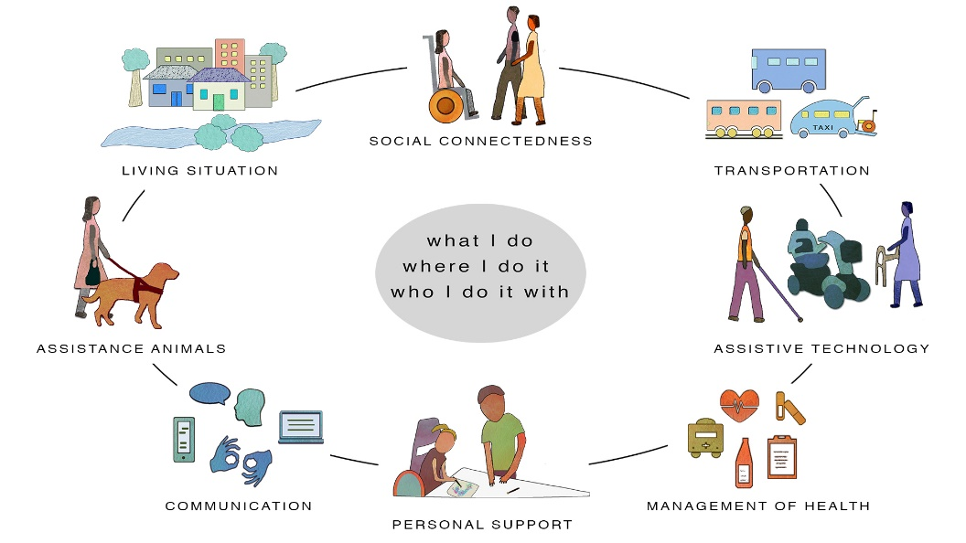
You can use the Capability Wheel to guide person-centred conversations with your client about their emergency planning. This will help bridge any gaps in your client’s preparedness.
  - Bushfire Survival Plan template
CFA has put together a bushfire planning template for your clients. Ideally, they fill this out themselves or with a family member or person of trust. In some cases, your client will not have anyone to help them create a suitable plan.
They may need some extra support from you or someone from your organisation. The Bushfire Survival Plan template can be used to support your client with a person-centred conversation to decide:

When will they leave?
Your client needs to decide what their trigger is to leave: Severe, Extreme, Code Red Fire Danger rating? Do they leave the night before or early in morning?

Where will they go?
Your client needs to consider where they could stay overnight or just for the day.

How will they get there?
Your client needs to make sure they have planned their transport and have a back-up plan. If it relies on public transport, do they have a timetable and is the service operating? If it is reliant on others, do they have the phone numbers written down? If they need to take a pet, can they travel this way?

What will they need to take?
Your client must prepare an emergency kit ahead of the summer in case they need to leave in a hurry. Anything that is essential to your client’s life for 24-48 hours needs to be included.

Who are their support people?
Is there anyone who needs to have a copy of the plan? Are they relying on someone for transport or accommodation? Does your client have a case manager who needs to know they’re leaving, or an agency to call?

When will they return?
Every plan to leave must include a plan to come home. How will your client know it’s safe to come home? How will they get home?
If your client would like to consider all emergencies in their planning, a PCEP Workbook is available on the website www.collaborating4inclusion.org/pcep It is a companion resource to the PCEP Toolkit that helps individuals self-assess their support needs and develop and document their personal emergency preparedness plan.
  - Conversations and time
Conversations about bushfire planning don’t need to happen all at once. It is ok to have a conversation over a few weeks. And in many cases the conversations are what help create a meaningful bushfire plan in the end.

Clients who choose not to leave
  - Some of your clients may choose to stay and defend their property or some may simply not want to leave.
The important thing for you to know is that they have a right to make this choice and you have no responsibility to help them create a comprehensive survival plan if they choose to stay and defend.
CFA advises that children, older people and people with specials needs or a disability should be well away from the threat.
For more information on the requirements to defend a home, see page 19 of this resource.
It can feel challenging when you have a client who does not want to leave their home.
All you can do is provide them with suggestions. If you have permission you can follow up with their family about their situation. It is possible that the family is already aware and has a plan in place.
If not you can ask if they have thought about what they would do.
Refer to your own organisation’s policies and procedures on working in high fire risk areas during summer.
While you have a duty of care to your client, you also need to manage your own safety during the summer. It will be unsafe to visit some locations on Code Red, Extreme and Severe days.

Making this all work
  - Your organisation will likely have policies and procedures about supporting clients and helping them with their Bushfire Survival Plan.
  - You should follow those procedures where they exist.
It is worth considering these simple steps to help improve the fire safety with your client:
Ask first | Ask your clients in high fire risk areas if they have a Bushfire Survival Plan. If they do, suggest that it is kept in a visible place so family, friends and other carers can see it.
No plan | If your client doesn’t have a plan, suggest that they create their plan using the template provided. Check in with them in a couple of weeks.
Need help | If your client needs help, suggest that a family member or friend could help them create their plan.
Plan assistance | If your client needs help and doesn’t have any family or friends who could help them with their plan, offer to help where you can.
If there are some clients who you feel do not have adequate plans and you want to follow up please use the referral pathway on the next page.

Referral pathway

My client does not have an adequate Bushfire Survival Plan
Refer back to your own organisation to a suitably trained staff member.

My organisation does not have anyone else to help
Contact a family member to tell them about your concern and ask that they assist the client.

My client has no family or the family cannot help. What should I do?
With their permission, refer your client to CFA to have a property advice visit. This will give the client advice about the bushfire risk and need for property preparedness.
Refer your client to the Municipal council for the following options:

Option1:
Service providers can ask for client to be place on the Vulnerable Persons Register.

Option2:
Ask council to activate Red Cross to conduct REDI Plan.

Contact CFA
Contact your local CFA Community Engagement Coordinator at an office near you to:
- refer a client to have a property visit
- arrange face-to-face bushfire safety training for your workplace
- access any further advice and information about bushfire safety.
For any other enquiries relating to this resource and training, you can email CFA at clientreferral@cfa.vic.gov.au

South East Region
District | Location | Email | Telephone
District 8 | Dandenong South | admin.d08@cfa.vic.gov.au | 03 9767 1800
District 9 | Warragul | admin.d09@cfa.vic.gov.au | 03 5624 1900
District 10 | Sale | admin.d10@cfa.vic.gov.au | 03 5149 1000
District 11 | Bairnsdale | admin.d11@cfa.vic.gov.au | 03 5153 7400
District 27 | Morwell | admin.d27@cfa.vic.gov.au | 03 5120 3700

North East Region
District | Location | Email | Telephone
District 12 | Seymour | admin.d12@cfa.vic.gov.au | 03 5735 3100
District 13 | Chirnside Park | admin.d13@cfa.vic.gov.au | 03 8739 1300
District 22 | Shepparton | admin.d22@cfa.vic.gov.au | 03 5833 2400
District 23 | Wangaratta | admin.d23@cfa.vic.gov.au | 03 5720 2300
District 24 | Wodonga | admin.d24@cfa.vic.gov.au | 02 6043 4400

North West Region
District | Location | Email | Telephone
District 2 | Kangaroo Flat | admin.d02@cfa.vic.gov.au | 03 5430 2200
District 14 | Melton | admin.d14@cfa.vic.gov.au | 03 8746 1400
District 18 | Swan Hill | admin.d18@cfa.vic.gov.au | 03 5036 2800
District 20 | Kerang | admin.d20@cfa.vic.gov.au | 03 5450 9400

South West Region
District | Location | Email | Telephone
District 4 | Casterton | admin.d04@cfa.vic.gov.au | 03 5554 2309
District 5 | Hamilton | admin.d05@cfa.vic.gov.au | 03 5551 1500
District 6 | Colac | admin.d06@cfa.vic.gov.au | 03 5232 5600
District 7 | North Geelong | admin.d07@cfa.vic.gov.au | 03 5240 2700

West Region
District | Location | Email | Telephone
District 15 | Wendouree | admin.d15@cfa.vic.gov.au | 03 5329 5500
District 16 | Ararat | admin.d16@cfa.vic.gov.au | 03 5352 9600
District 17 | Horsham | admin.d17@cfa.vic.gov.au | 03 5362 1700

Dial: 000
If you see smoke, flame or embers

VicEmergency Hotline
1800 226 226
For fire warnings and updates

Translating and Interpreting Service
131 450

National Relay Service
1800 555 677
cfa.vic.gov.au
ffm.vic.gov.au
emergency.vic.gov.au

Villeneuve, M., Sterman, J., & Llewellyn, G.L. (2018). Person-Centred Emergency Preparedness: A process tool and framework for enabling disaster preparedness with people with chronic health conditions and disability. Centre for Disability, Research and Policy, University of Sydney, NSW 2006.
Villeneuve, M. (2019). ). Increasing active involvement of people with disability in disaster risk reduction. Australian Journal of Emergency Management, 34 (4), https://knowledge.aidr.org.au/resources/ajem-october-2019-increasing-involvement-of-people-with-disability/
The Capability Wheel is taken from the Person Centred Emergency Preparedness (PCEP) User Guide, developed by The University of Sydney. You can access the PCEP Toolkit that consists of the User Guide and three videos to help you get started. The Toolkit can be found at www.collaborating4inclusion.org/pcep/

