Part 1 – Creating a User Account (if you don’t have an account already)
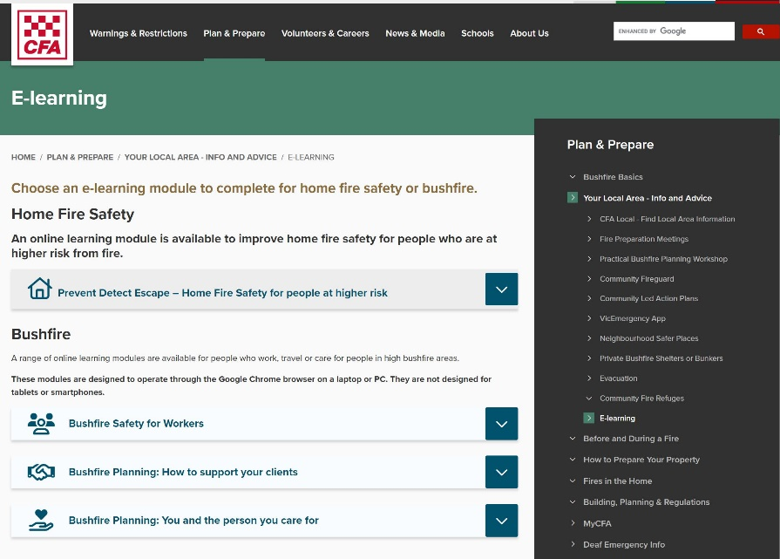 | Go to: www.cfa.vic.gov.au/workers  Select ‘Bushfire Planning: You and the person you care for’
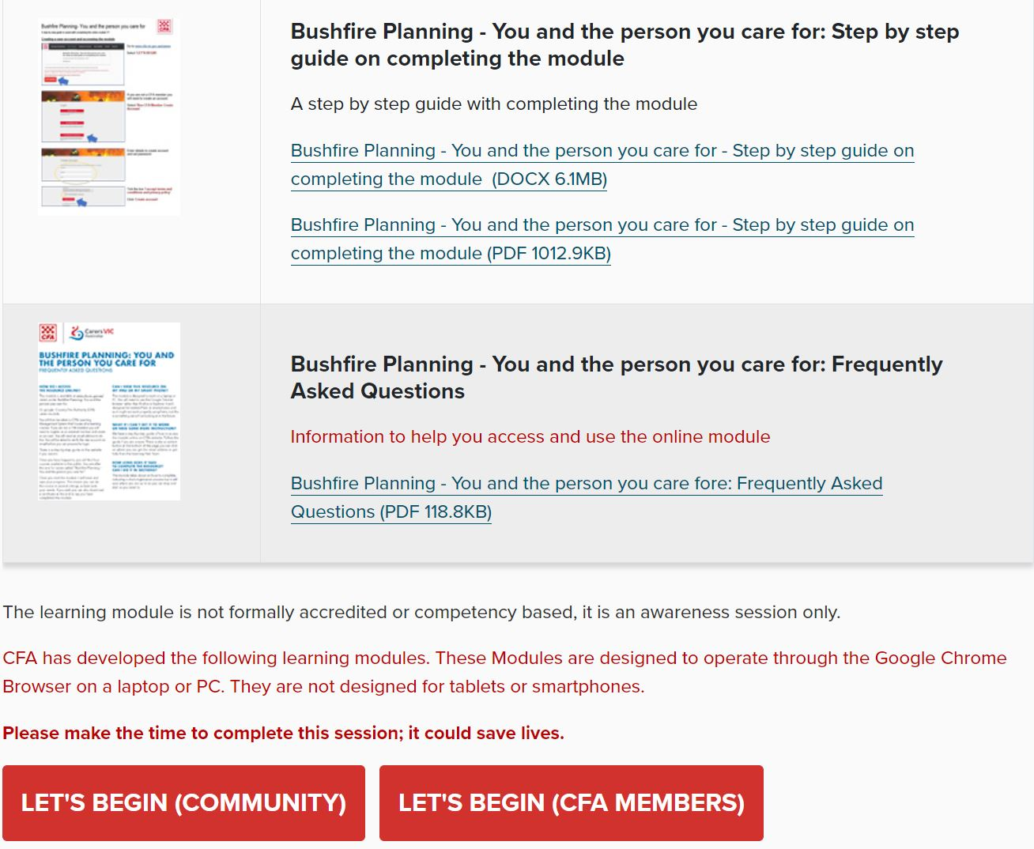 | Scroll down the page  Select ‘Let’s Begin (Community)’
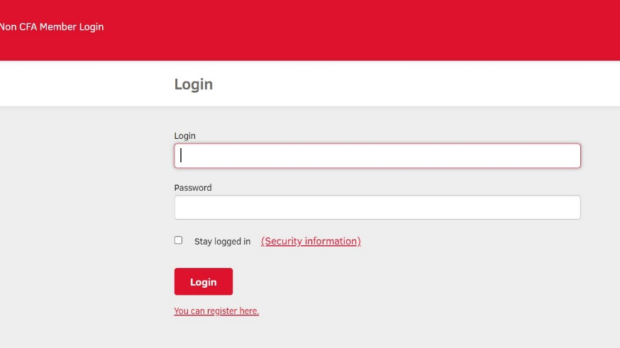 | Select ‘You can register here’
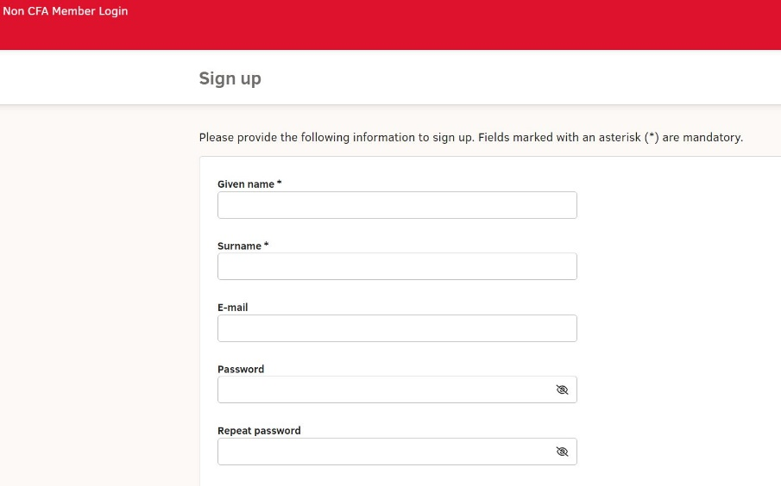 | Fill out all the details on the ‘Sign up’ page and record your password for future login  Your reason for access is most likely to be ‘As part of my work’  Select your organisation from the drop-down ‘Organisation’ list if it is there. If not there, add it in the ‘Other organisation’ box
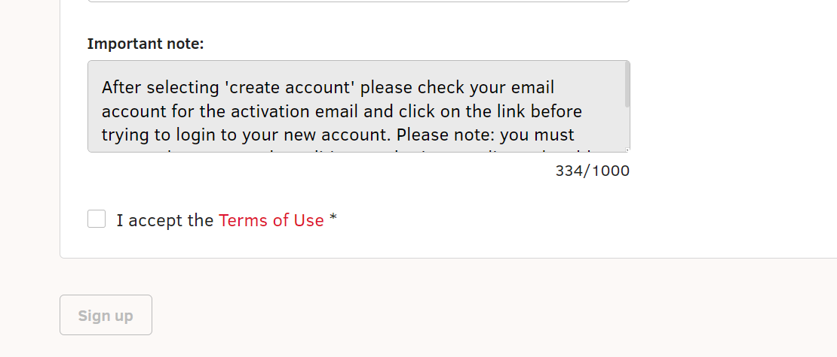 | Click the ‘I accept the Terms of Use’ box  Click the ‘Sign up’ box
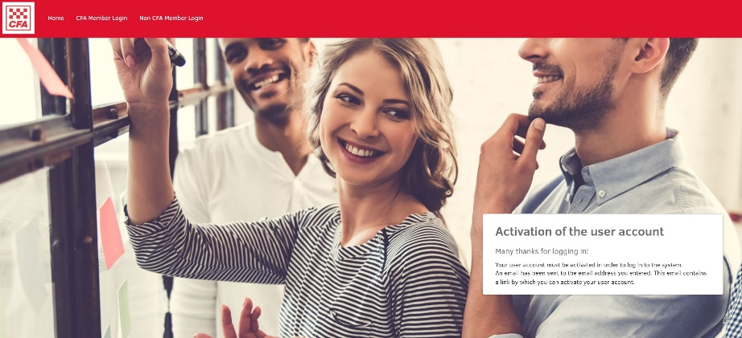 | You will receive TWO emails  One email informs you that ‘Your CFA Learning Hub Access has just been created!’ (no need to click links in this email)  A second email is for ‘Activating your login information’ (this is the email you’ll need)  Check your Junk Mail folder if the emails don’t arrive in your Inbox
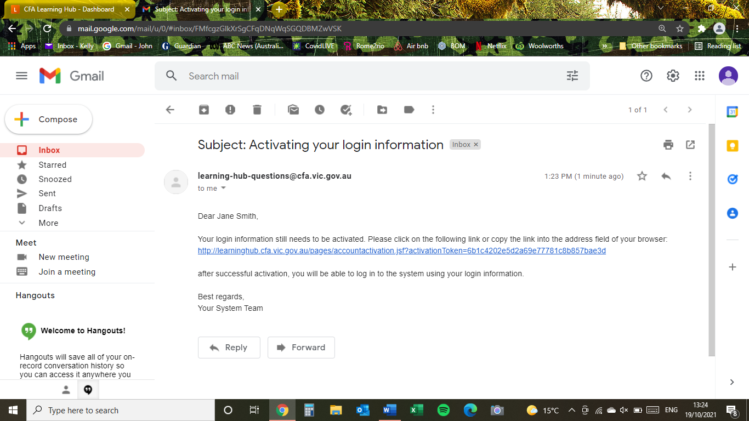 | Open the ‘Activating your login information’ email  Click on the link to activate your account  Contact:  learning-hub-questions@cfa.vic.gov.au  if you are having any problems
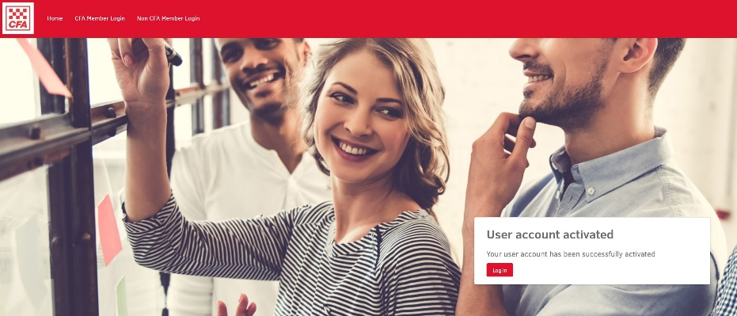 | Click on the red ‘Log in’ box to access your new account
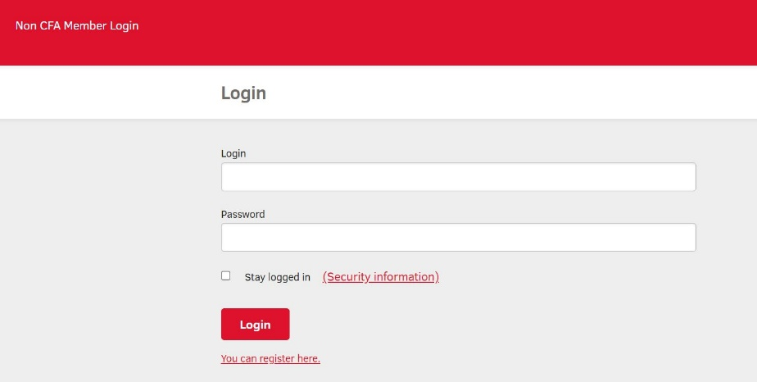 | Enter your ‘Login’ details (your email address used during account setup)  Enter your ‘Password’ (which you created during account setup)  Click ‘Login’
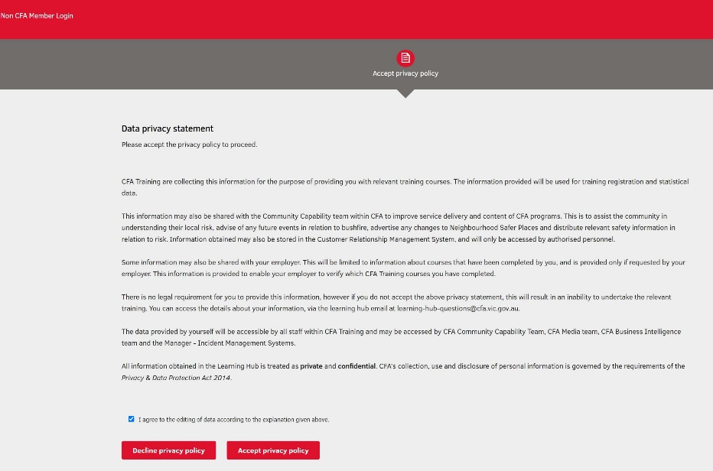 | Click the checkbox ‘I agree to the editing of data according to the explanation given above’  Click the red ‘Accept privacy policy’ box  This will take you into Learning Hub

Part 2 – Accessing the Bushfire Planning: You and the person you care for module
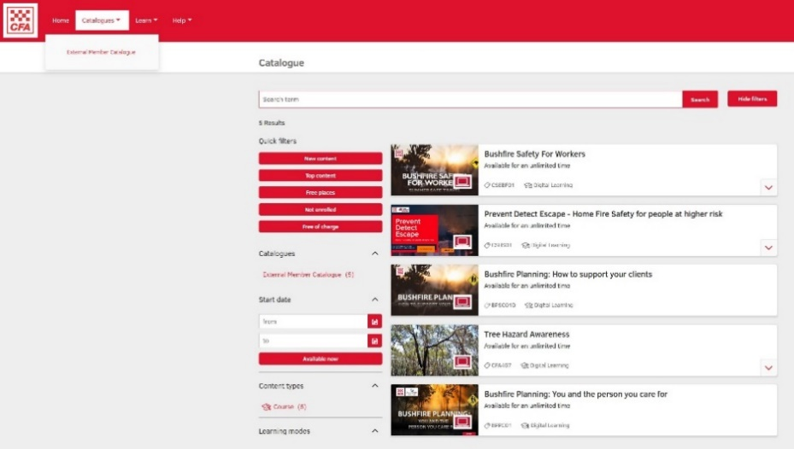 | You are now in Learning Hub  (learninghub.cfa.vic.gov.au)  Don’t click on the red ‘Enrol’ box on the screen that comes up. Instead, we’ll bring up all the modules available to you to select from, so you know where to find them  Click on the ‘Catalogues’ menu item in the upper left menu area  Click on the ‘External member catalogue’ menu item that drops down  You will now be able to see the online modules that are available for you to complete  Click on the ‘Bushfire Planning: You and the person you care for’ box to get started
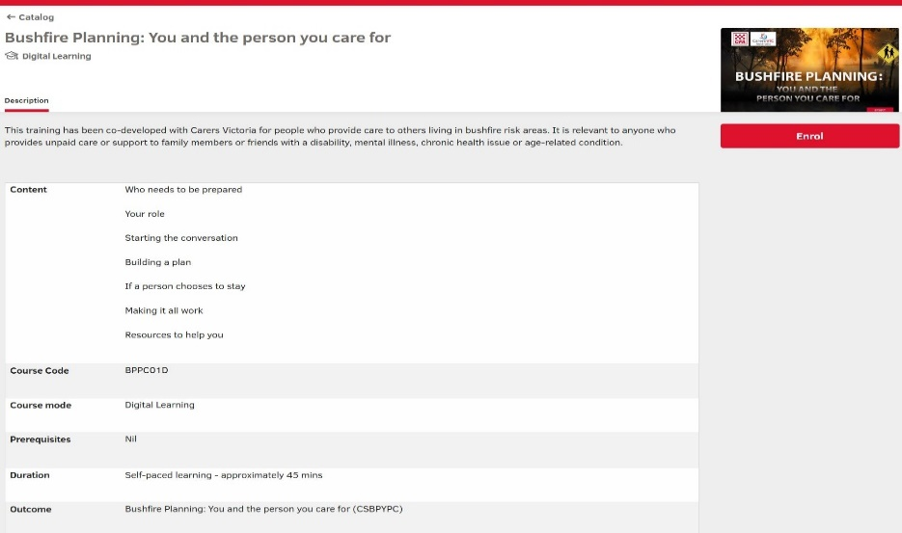 | Click on the red ‘Enrol’ box to enrol for the module
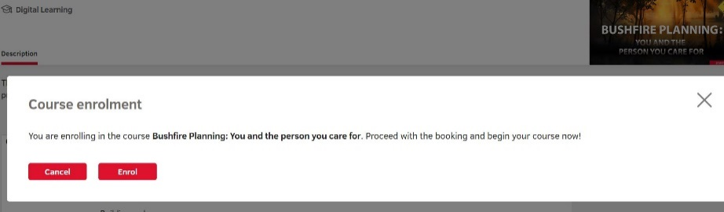 | Click on the second red ‘Enrol’ box to comes up on the screen
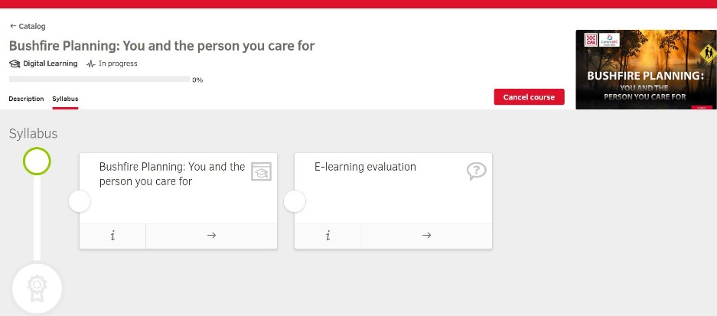 | You can now start the module by clicking on the title ‘Bushfire Planning: You and the person you care for’ or the ‘right-pointing’ arrow. Follow the module instructions  Once the module is completed it will turn green  If you exit and return and return you can resume where you left off by clicking on the module or the yellow circle ‘In progress’ icon ‘

Part 3 – Accessing a Certificate of Completion
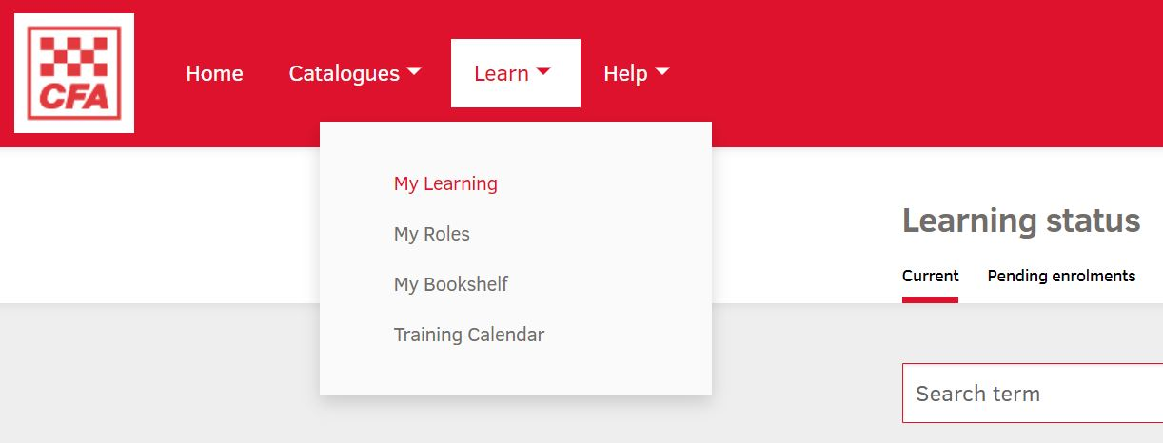 | Once you have completed a module you can download a Certificate of Completion  You can either download your certificate straight away or do it later  Download the certificate by clicking on ‘Learn’ then ‘My Learning’ at the top of the Learning Hub page menu
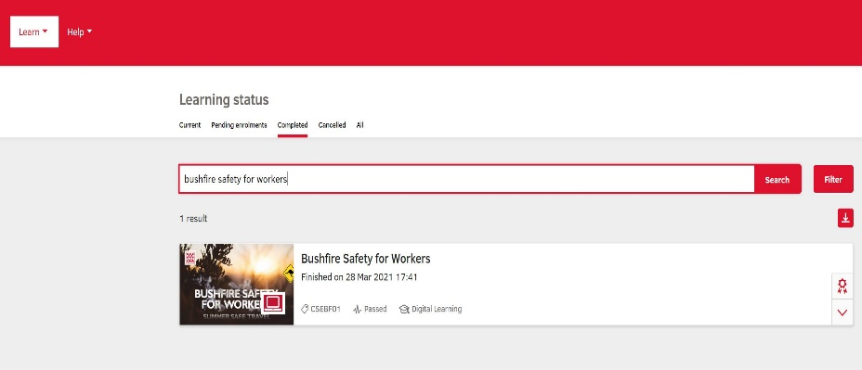 | Click on the ‘Completed’ menu item in the ‘Learning Status’ menu to bring up a list of your completed modules  In this case ‘Bushfire Safety for Workers’ is shown. If you have completed other modules they will also be on the list and the process is the same  Click on the small ‘certificate’ icon on the right of the screen. Your certificate of completion will download to your computer
Part 4 – Returning to Learning Hub … and logging back in
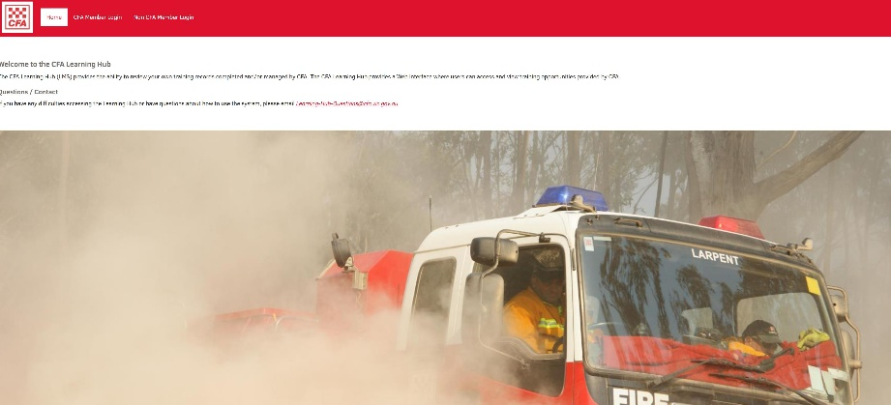 | To return to Leaning Hub on your computer go to:  learninghub.cfa.vic.gov.au
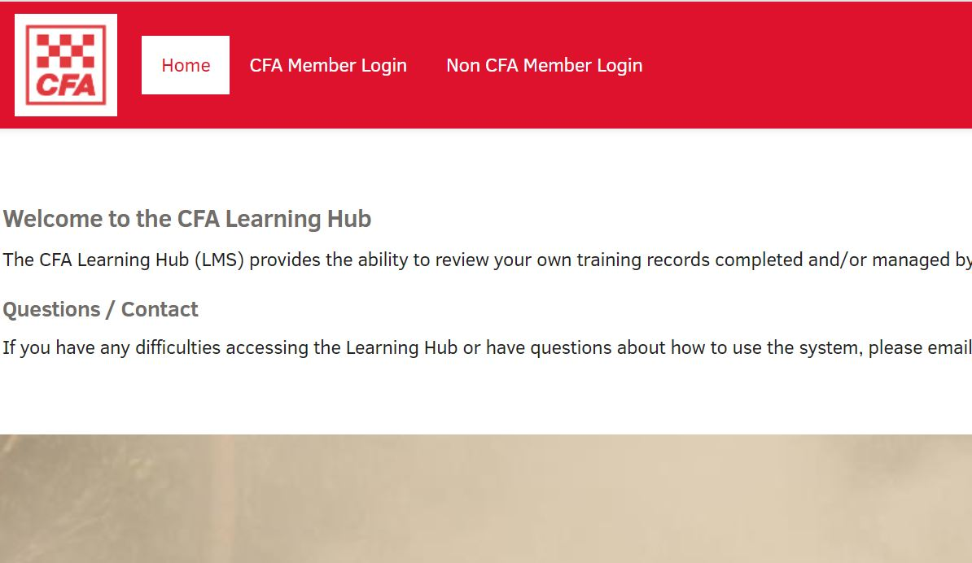 | Click on ‘Non CFA Member Login’ in the menu
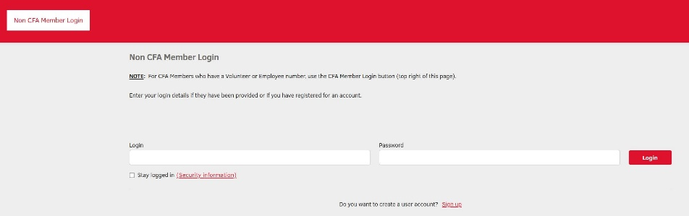 | Enter your ‘Login’ details (your email address used during account setup)  Enter your ‘Password’ (which you created during account setup)  Click the red ‘Login’ box  This will take you to your personal Learning Hub page where you can review learning, continue modules, start new modules etc

Part 5 - Frequently Asked Questions

- What if the module is not working properly on my computer?
Most likely it is a problem with your internet browser. Make sure you are using a recent version of either Chrome or Firefox as Internet Explorer may not run the module properly.

- Can I do the module on my phone?
This online module is designed to operate from a computer or laptop and may not work effectively from your phone. It will also make it hard to see some of the text on a small phone screen.

- Can I do the module again?
Once completed you can still go back and do the module again. In fact, CFA recommends you do a refresher every year. However, once you have completed it, it will list your record as completed.

- Who do I contact with any feedback?
You can contact communityprograms@cfa.vic.gov.au to email us any feedback or questions you have.

