Case Study:
Farm Fire Safety
Lake Rowan and Moyston fires - 2015


Introduction
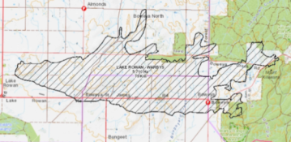
In late 2014 and early 2015 a number of bushfires occurred in Victoria as a result of lightning strikes. These fires burnt through farm land with a mix of lifestyle properties. The fires burnt rapidly with some locals advising that the fire travelled at speeds of approximately 20 km/h at various times.
Figure 1 – Lake Rowan fire
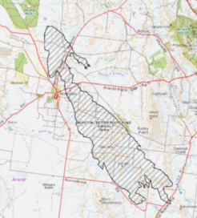
These fires occurred during times of peak activity. In the North East Region they experienced in excess of 350 fires over a two day period caused by lightning. The vast majority of these fires were extinguished by CFA Brigades or private appliances.
Figure 2 – Moyston fire
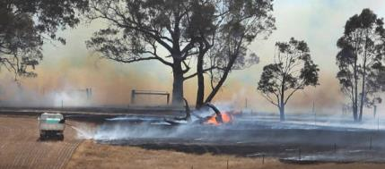
In a small number of cases, these fires spread rapidly. Two of those fires which are the focus of this Case Study are the Lake Rowan fire which is located west of Wangaratta and the Moyston fire which was south west of Ararat. Both of these fires spread rapidly under high wind speeds and challenged responders and the community.

Figure 3 – Private appliance
fighting the Moyston fire

Overview of fires
Fire name | Size | House loss | Houses within perimeter | Other losses | Weather and fire behaviour
Lake Rowan | 5,710 Ha | Nil | 31 | 1 Derelict house  Sheds  Stock | The fire burnt under a North Westerly for a short period of time. A westerly change occurred and was the key influence over the majority of the fire spread.
Moyston | 4,454 Ha | 3 | 28 | Sheds  Stock  Bungalows | The wind direction for the majority of the fire was from the north west. Wind speed was variable with some areas exposed to 30 km/h.

Farm fire safety
A key standout from these fires is the number of houses that survived. The houses were primarily associated with farms and due to the long term management of fire risk, they performed very well when compared to fires in other non-farming areas. After an examination of the available information and site inspections the following was identified:
- Farmers within the fire areas had an excellent understanding of fire behaviour and the treatments required to manage the risk from grassfires.
- Key fire safety treatments utilised by farmers included:
The paddocks in the north and western areas of the home were well managed by the appropriate selection of crops or had been eaten out by livestock.
Ensuring the immediate area around the home was designed to offset the impact of a fire. This included the driveway circling the house, lawns and garden beds well watered and the appropriate placement of machinery sheds to further protect the house.

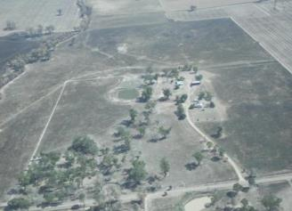

- CFA in conjunction with other agencies and local community groups had undertaken extensive fire safety education programs in the surrounding areas including Field Days, Livestock Sales and Agricultural Shows. These events utilised CFA’s ‘On the Land, Agricultural Fire Management Guidelines’.

What works
- Utilise farmers who are also locals to communicate fire safety information within their local area.
- Ensure CFA’s publication ‘On the Land’ is utilised whenever engaging with farmers or landowners in grassland areas.
- Ensure fire safety considerations are integrated with farm planning processes.
- Continue to develop local solutions led by locals. Meet and discuss fire safety with all available community groups.
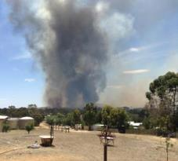
- Support industry to develop specific packages for items including sprinklers and farm fire fighting capability.

Strong local knowledge through regular burning off and the majority of farmers are also CFA volunteers.
Management of hay storage areas by ensuring hay was stored in areas with limited combustibles.

BARE PLAN TO SAVE STOCK
FARMERS in bushfire-prone areas have been urged to set up stock containment areas on their farms to protect livestock.  BlazeAid founder and president Kevin Butler (pictured in his containment area) has made the call, driven by the high number of stock losses from grassfires and bushfires.  “How many blokes jump on a fire truck (at the outbreak of a fire in their local area) and come back to find their stock burnt up?” Mr Butler said.  “From my experience with fires, animals don’t have a chance.”  “If you look at the Moyston fires, farmers were saying ‘I only had minutes’ before the fire arrived.”  Mr Butler practices what he preaches.  He has set up a number of stock containment areas on his farm at  Kilmore East. All that was required was careful planning.  “It’s not rocket science, just common sense,” he said.  “You just have to plan over years to get them in place.” | Mr Butler sprays out each area in August or September, then burns  them when they are dry enough.  Any grass not burnt is eaten when he starts feeding stock in the containment area.  Each haven is fenced off and has a water trough or a dam.  On Total Fire Ban days, Mr Butler herds his sheep into the stock containment areas and they stay there until the threat is over.  “When a fire breaks out, there is not enough time to start moving them,”  he said.  “And when it is hot, they won’t move for you, anyway. So I put them in there when there is a high fire threat and I can sleep better at night.”  Mr Butler said farmers should be able to reduce their insurance  premiums by installing stock containment areas.  PETER HEMPHIL  JANUARY 28, 2015 WEEKLYTIMES

