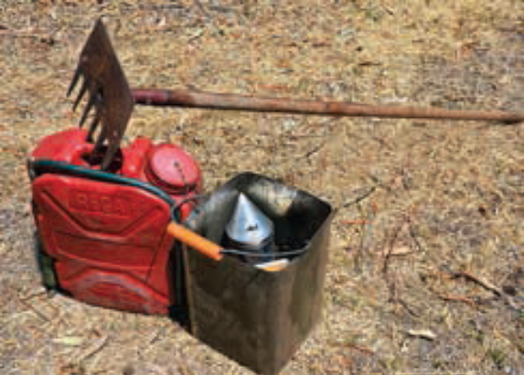
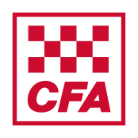
Guidance for Beekeepers
during the Fire Danger
Period and Total Fire Ban
Days in the Country Area of Victoria
May 2023 cfa.vic.gov.au

This brochure provides general guidance as to what beekeepers can and can’t do during declared Fire Danger Periods in the Country Area of Victoria when fires in the open air are legally restricted and on days of Total Fire Ban. Other conditions may apply to areas managed by Department of Energy, Environment and Climate Action (DEECA) and Fire Rescue Victoria (FRV). Please check the conditions that apply where you are operating.
Legislation
Section 34A of the Country Fire Authority Act 1958 defines in the Open Air as:
- A fire is in the open air if it is in any place other than within a permanent structure.
- In this section permanent structure –
- means a structure of a permanent kind consisting of a roof and fully enclosed on all sides;
- includes a caravan; and
- Does not include a tent.
Any fires within one, two or three sided structures/buildings are considered to be in the “open air”.
CFA declares Fire Danger Periods by municipality during periods of increased fire risk.
During The Fire Danger Period (FDP) - not on days of Total Fire Ban
If a fire (flame or any combustion producing heat) is used for the purpose of extracting honey or a bee smoker is used during relocating bees or opening hives during routine hive management, a permit for that fire in the open air is not necessary when the following is in place:
- A person is in attendance at all times who has the capacity and means to extinguish the fire while a smoker is operating (i.e. when combustion of fuel to produce smoke is occurring).
- A fire-resistant shield or guard is in place to stop sparks and/or hot particles from being emitted. A well maintained and correctly functioning smoker can be considered to fulfil this function.
- An area of at least 1.5 metres in all directions from the operation is clear of all flammable material or the area is wetted down. Flammable material can be defined as combustible material that is likely to burn easily. Other materials that are able to burn but are not likely to burn easily such as beehives and beehive pallets are considered combustible but not flammable.
- There is available for immediate use in the event of a fire occurring, a reticulated water supply or an effective water spray pump of the knapsack pattern with a tank capacity of not less than nine litres and fully charged with water.

Total Fire Bans (TFBs)

Total Fire Bans (TFBs) are declared by the CFA on days when fires are likely to spread rapidly and be difficult to control and can be declared for any area of the State. The use of smokers on a TFB is illegal unless the beekeeper has been issued a Section 40 permit. This permit must be in their possession at all times when using smokers. Section 40 permits can be applied for at:
- CFA District offices for the Country Area of Victoria.
- DEECA offices for forests, national parks, protected public lands and fire protected areas.
- FRV offices in the Fire Rescue Victoria District.
The following actions are also advised:
- Apiarists using smokers should remain informed of local fire danger conditions.
- Smokers should not be used in strong windy conditions as stray sparks could ignite fires.
- Smokers must be kept in good working condition.
- Smokers with double vents in the bellows are preferred because they prevent hot ash being sucked out of the fire box.
- When the smoker is no longer required, the fire should be extinguished and the smoker placed in a fire proof container. One method of extinguishing the fire in the smoker is to stop the air flow by plugging the outlet nozzle with tightly rolled wet material.
- Never travel from apiary to apiary with a lit smoker.
- When locating hives, search for places with little or no flammable vegetation within - 1.5 metres of the hives.
- Those unfamiliar with the use of and operation of smokers should participate in relevant training.
- A rake hoe is recommended, as it is useful for clearing space and to deal with minor ignitions.

